SUBCOURSE EDITION
SS0655 7

SUPERVISE OPERATION OF TEAM:
WITHIN A RADIO NET

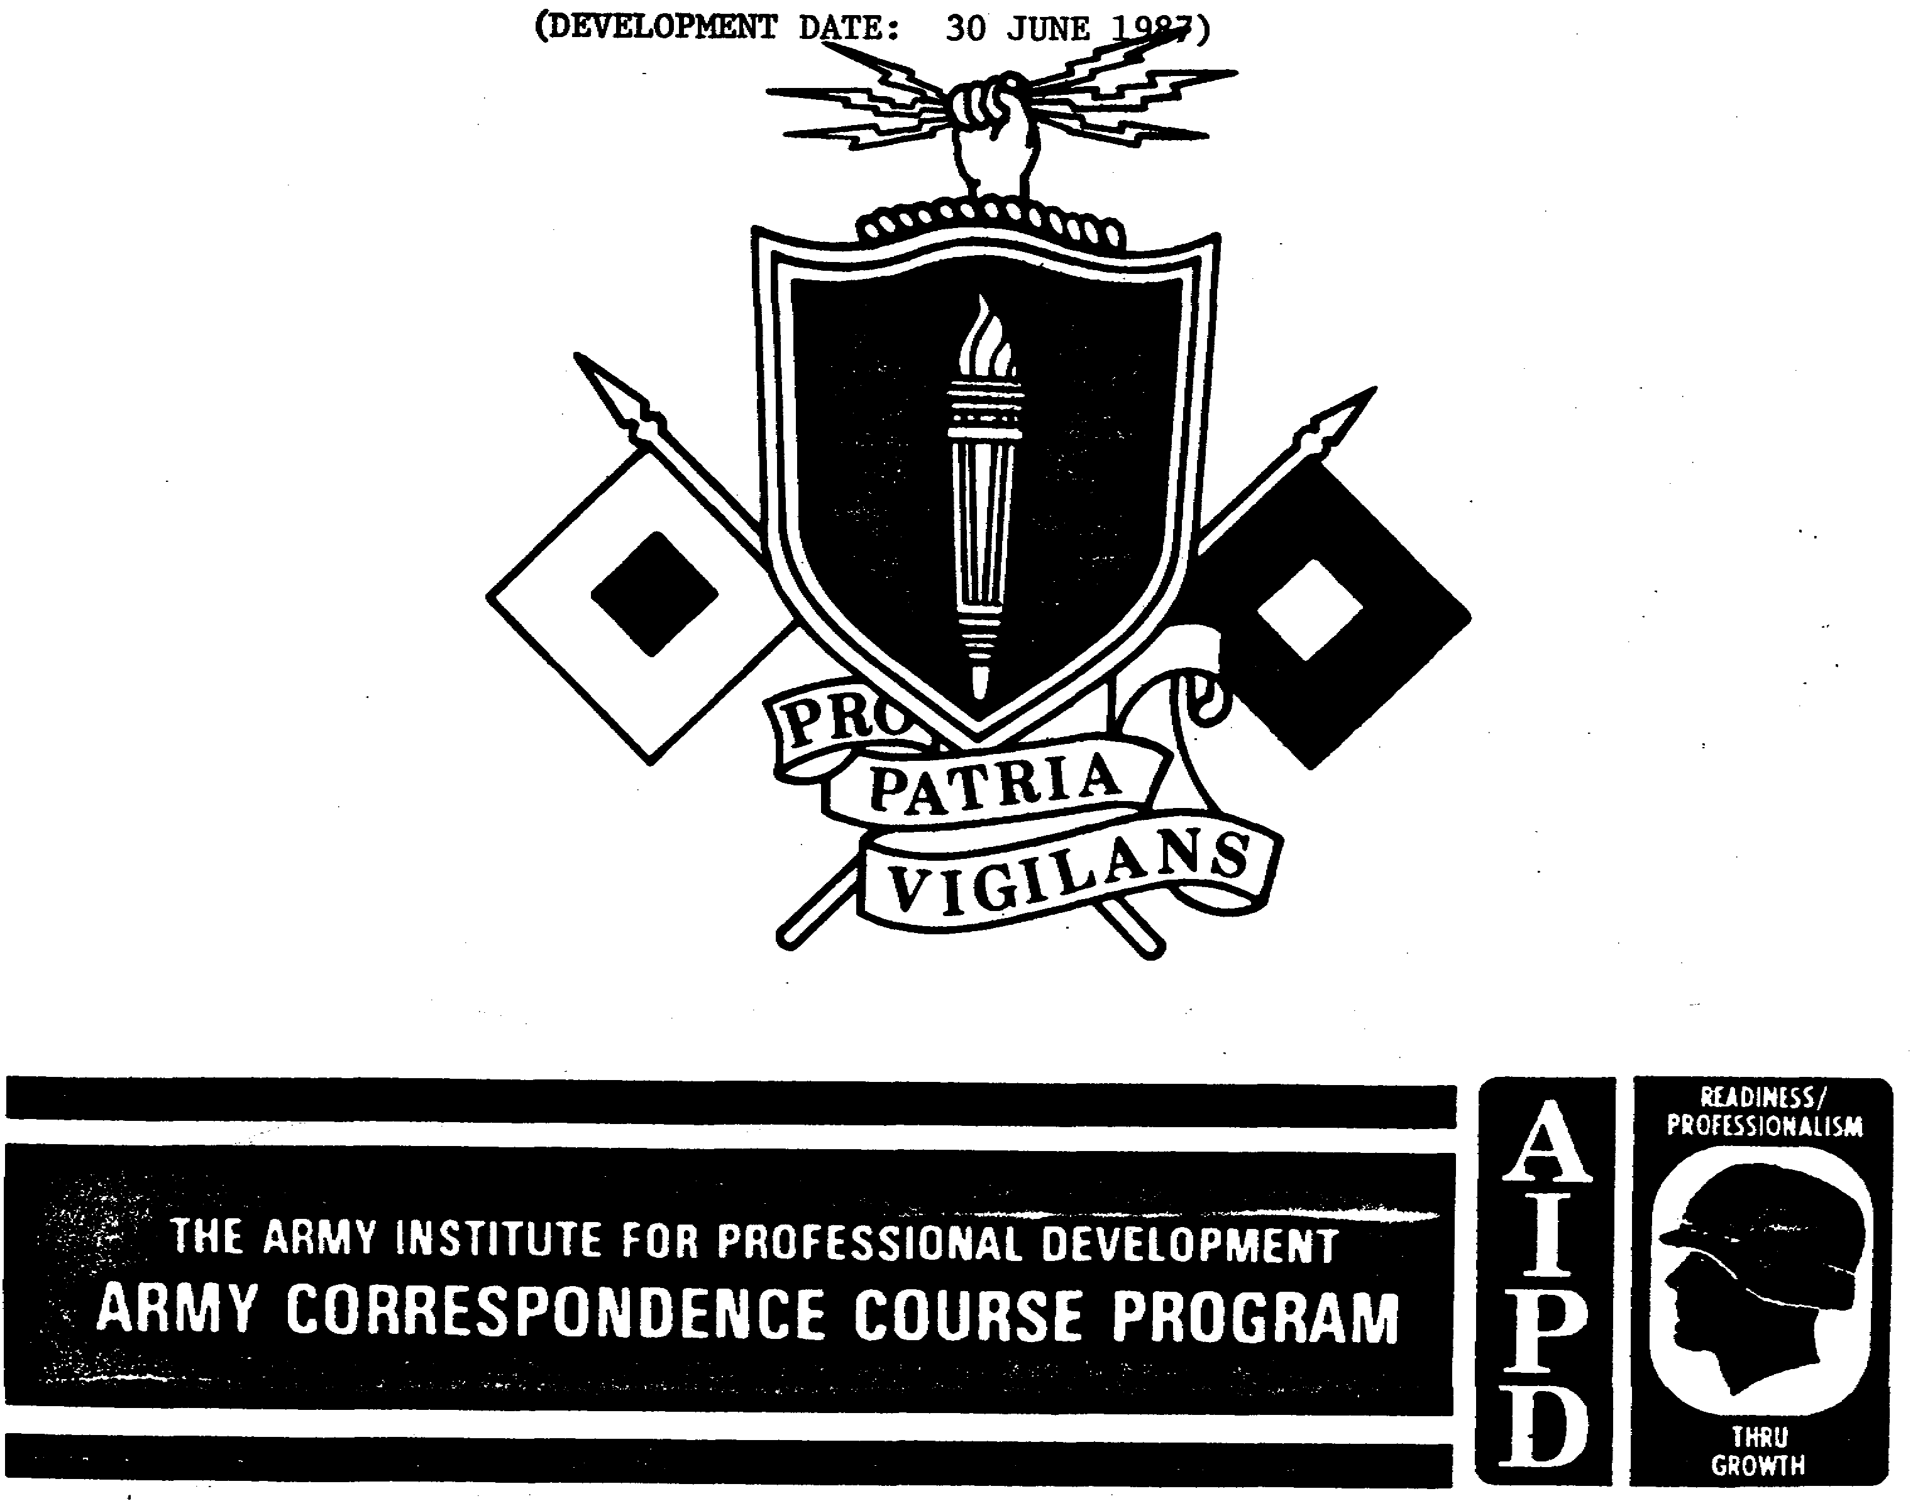

US ARMY SINGLE CHANNEL RADIO OPERATOR
MOS 31C SKILL LEVEL 2 COURSE

SUPERVISE OPERATION OF
TEAM WITHIN A RADIO NET

SUBCOURSE NO. SS0655-7

(Development Date: 30 June 1987)

US Army Signal Center and Fort Gordon
Fort Gordon, Georgia

Three Credit Hours

GENERAL

The Supervise Operation of Team Within a Radio Net subcourse, part of the Single Channel Radio Operator Skill Level 2 course, is designed to teach the knowledge and skills necessary for performing the tasks related to the supervision of a radio team. The learning objective for the subcourse is as follows:

TASK: The student will supervise the operation of a team within a radio net.

CONDITIONS: Given changing and non-changing SOI data, ACP 125(*) with US Supplement 1, FM 24-35, TC 24-19, a net assignment, and without supervision.

STANDARDS: Identify the proper procedures for use of SOI, entering into, operating in, leaving, and executing duties as net control station in a radio net IAW ACP 125(*) with US Supplement 1, FM 24-35 TC 24-19, and SOI to the minimum standard by correctly responding to 80% of the multiple choice test.

This objective supports in whole or in part the SM Task Numbers and Titles listed below.

113-571-7005 Supervise operation of Team Within a Radio Net
113-571-1004 Operate in Radio Nets
113-571-1003 Establish, Enter or Leave a Radio Net
113-573-4006 Use the KTC 1400(*)
113-573-8006 Use an Automated SOI
113-573-6001 Recognize ECM and Implement ECCM

i
TABLE OF CONTENTS

Section Page

TITLE PAGE i

TABLE OF CONTENTS ii

Lesson 1: SUPERVISE RADIO TEAM'S USE OF SOI 1

Learning Event 1: Identify SOI Item Number
for the Assigned Unit 1

Learning Event 2: Locate the Correct SOI
Pages for Use 7

Practice Exercise 8

Learning Event 3: Determine the Call Sign,
Suffix/Expander, Operating Frequency and
Item Number Identifier 9

Learning Event 4: Identify the Correct
Authentication Table in Effect and
Demonstrate Proper Use 13

Practice Exercise 17

Lesson 2: SUPERVISE RADIO TEAM'S USE OF PROPER
PROCEDURES 23

Learning Event 1: Identify the Proper
Procedures to Enter a Radio Net 23

Practice Exercise 28

Learning Event 2: Identify the Proper
Procedures to Transmit and Receive
Traffic Within a Radio Net 29

ii

Learning Event 3: Identify the Proper
Procedures for Leaving a Radio Net 44

Practice Exercise 45

Lesson 3: SUPERVISE THE EXECUTION OF THE
DUTIES OF NET CONTROL STATION 47

Learning Event 1: Identify the Proper
Procedures to Open a Radio Net 47

Learning Event 2: Identify the Proper
Procedures for Directing Traffic in a
Radio Net 48

Learning Event 3: Identify the Procedures
for Closing a Radio Net 53

Learning Event 4: Identify the Procedures
for Requiring Stations to Authenticate and
Maintaining Transmission Security in a
Radio Net 55

Practice Exercise 59

ANSWERS TO PRACTICE EXERCISES PT 1-2

iii

LESSON 1
SUPERVISE RADIO TEAM'S USE OF SOI

TASK

Supervise radio team's use of SOI to acquire the information necessary to operate in a radio net.

CONDITIONS

Given changing and non-changing SOI data, a net assignment, and without supervision.

STANDARDS

Identify the correct call sign, suffix/expander, operating frequency, item number identifier, authentication table in effect and procedures for use of authentication table IAW FM 24-35 and the SOI by correctly responding to 70% of the multiple-choice test.

REFERENCES

Extracts of FM 24-35
SOI

Learning Event 1:
IDENTIFY SOI ITEM NUMBER FOR ASSIGNED UNIT

1. Signal Operation Instructions (SOI) are a series of orders issued for technical control and coordination of a command or activity. It provides guidance needed to ensure the speed, simplicity and security of communications. As a communications security (COMSEC) aid, SOI are to provide transmission security by limiting and impairing enemy intelligence efforts. The items in Figure 1-1 are normally contained in each document.

NOTE: SOI is being used IAW FM 24-35 Communications-Electronic Operations Instructions (The CEOI).

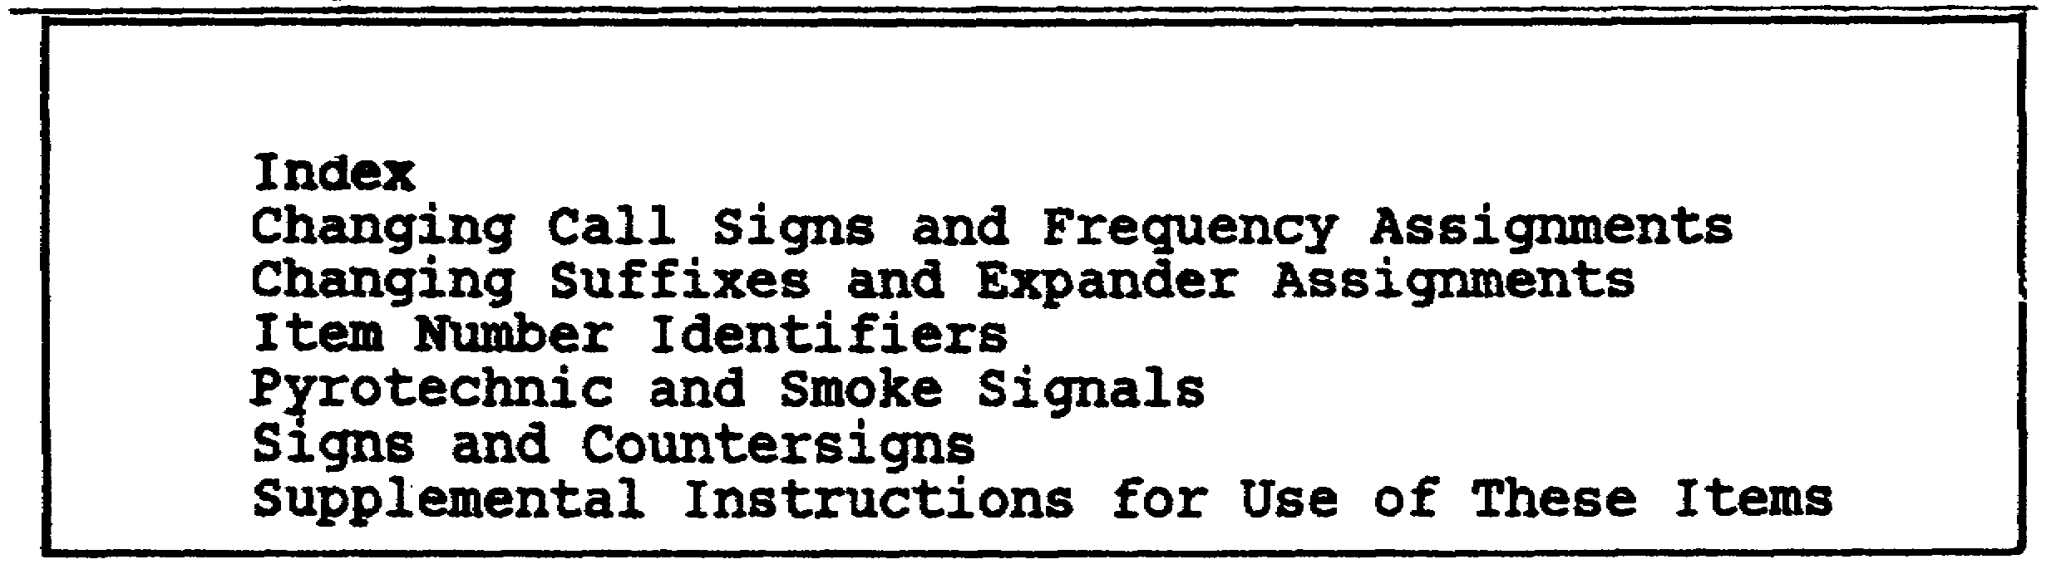

Figure 1-1. Contents of SOI.

1
2. SOI contain specific instructions for the operation of communications nets, systems and facilities of a command. Centrally produced SOI are in a concept called the communications packet. Under this concept, SOI are packaged in the exact quantity required by an organization.

3. The heart of the communications packet is a single page extract item shown in Figure 1-2. The extract item contains all information required by an element for a single time period. This includes call signs, frequencies, net types, suffixes/expanders, and sign and countersign assignments. The single page extract item eliminates the need to refer to several pages to obtain required information .

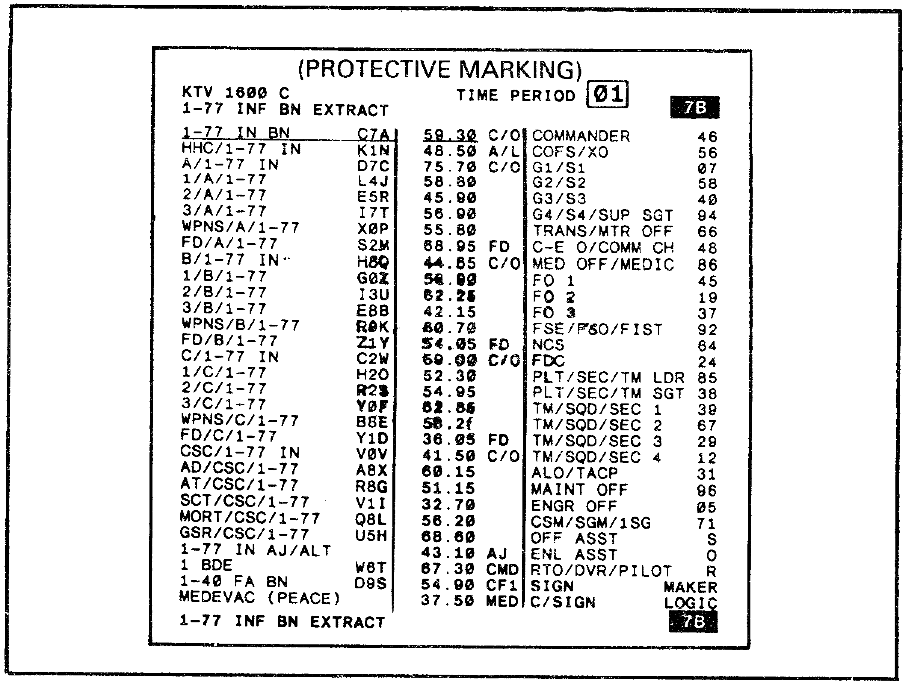

Figure 1-2. 1-77 Infantry Battalion.

4. An example of a quick reference item is shown in Figure 1-3. This item provides the user with a quick reference to all call signs and frequencies assigned to the command. The information provided in the quick reference items corresponds exactly with like information on the signal page extracts. To demonstrate this, compare the information underlined in Figures 1-2 and 1-3.

2

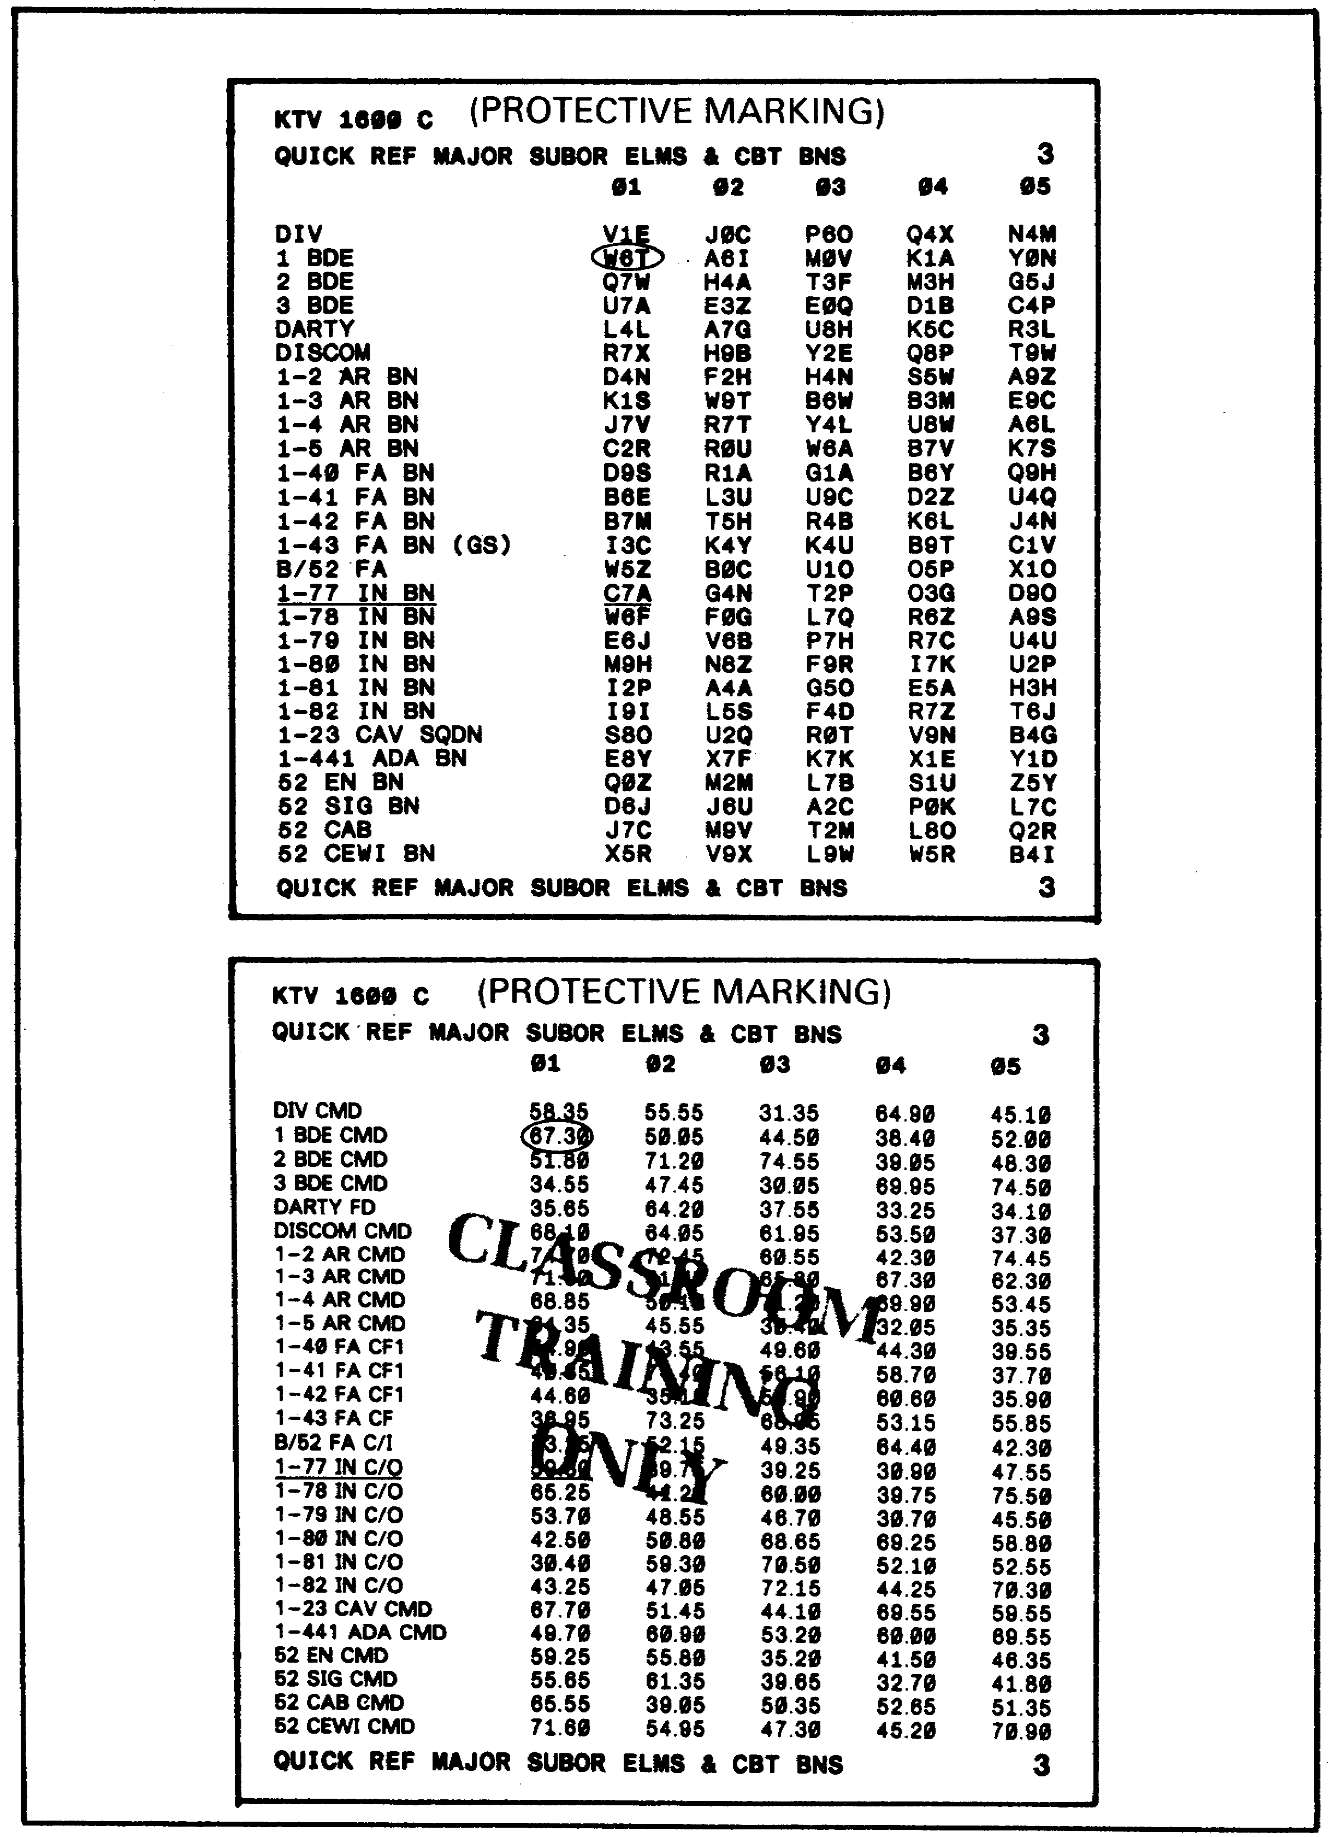

Figure 1-3. Quick Reference Items.

3

5. Each edition of the SOI consists of two segments. The first and major booklet is the changing data, and the second is the non-changing (infrequently changing) data booklet.

a. Changing data consists of the information we have already discussed. This data covers a 30-day time period, and is published in three 10-day time period booklets, changed on a daily (24 hours) basis.

b. The non-changing data is published in a separate booklet and consists of the SOI Supplemental Instructions. This booklet contains such items as index, handling/general instructions, sound signals, and ECCM procedures/MIJI reporting.

6. Each SOI carries its own unique numbers to provide an easy short title for SOI. The training edition has the short title, "KTV 1600 C". This number is assigned to the SOI for the fictitious 52nd Infantry Division (M) and remains unchanged. The short title designators assigned to SOI are listed in Figure 1-4.

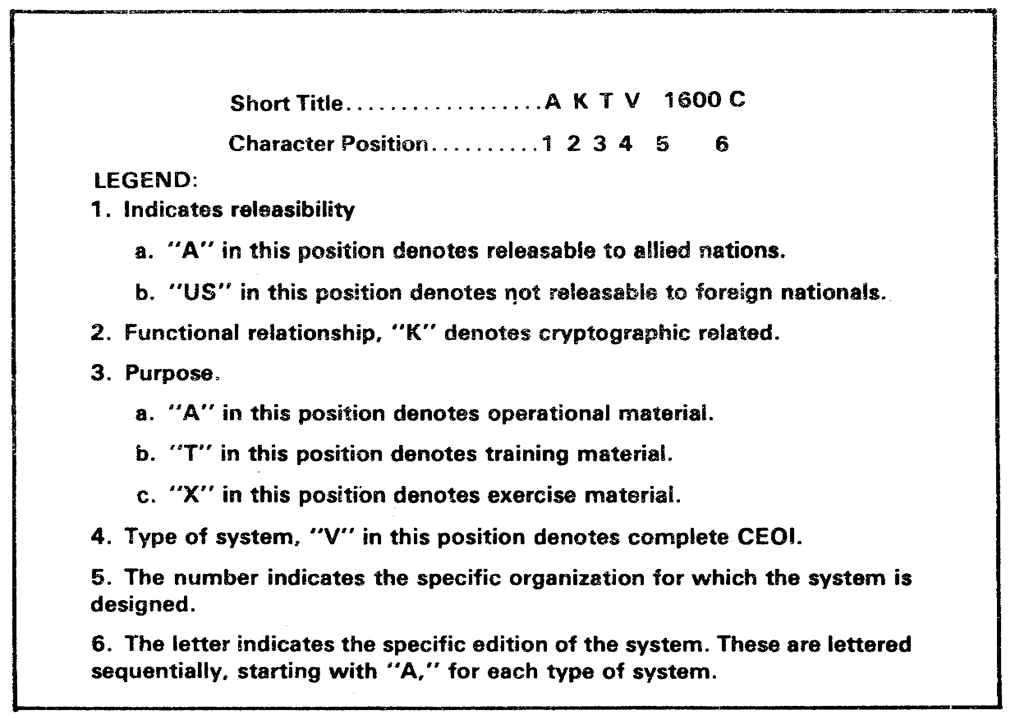

Figure 1-4. SOI Short Title Designations.

4

7. SOI items are numbered consecutively. The changing items start with item 1, which is always the index, and continue as far as required for the particular SOI. An example of this numbering system is shown in Figure 1-5. A letter is added to the basic item number to indicate subordinate echelons or additional items. For example, in Figure 1-5, item number 7 is assigned to the call sign and frequency items pertaining to 1st Brigade. Item numbers 7A through 7D pertain to subordinate elements. Call sign and frequency items for a particular element have the same item number (this pertains to items other than the single time period pages appearing in the communications packets).

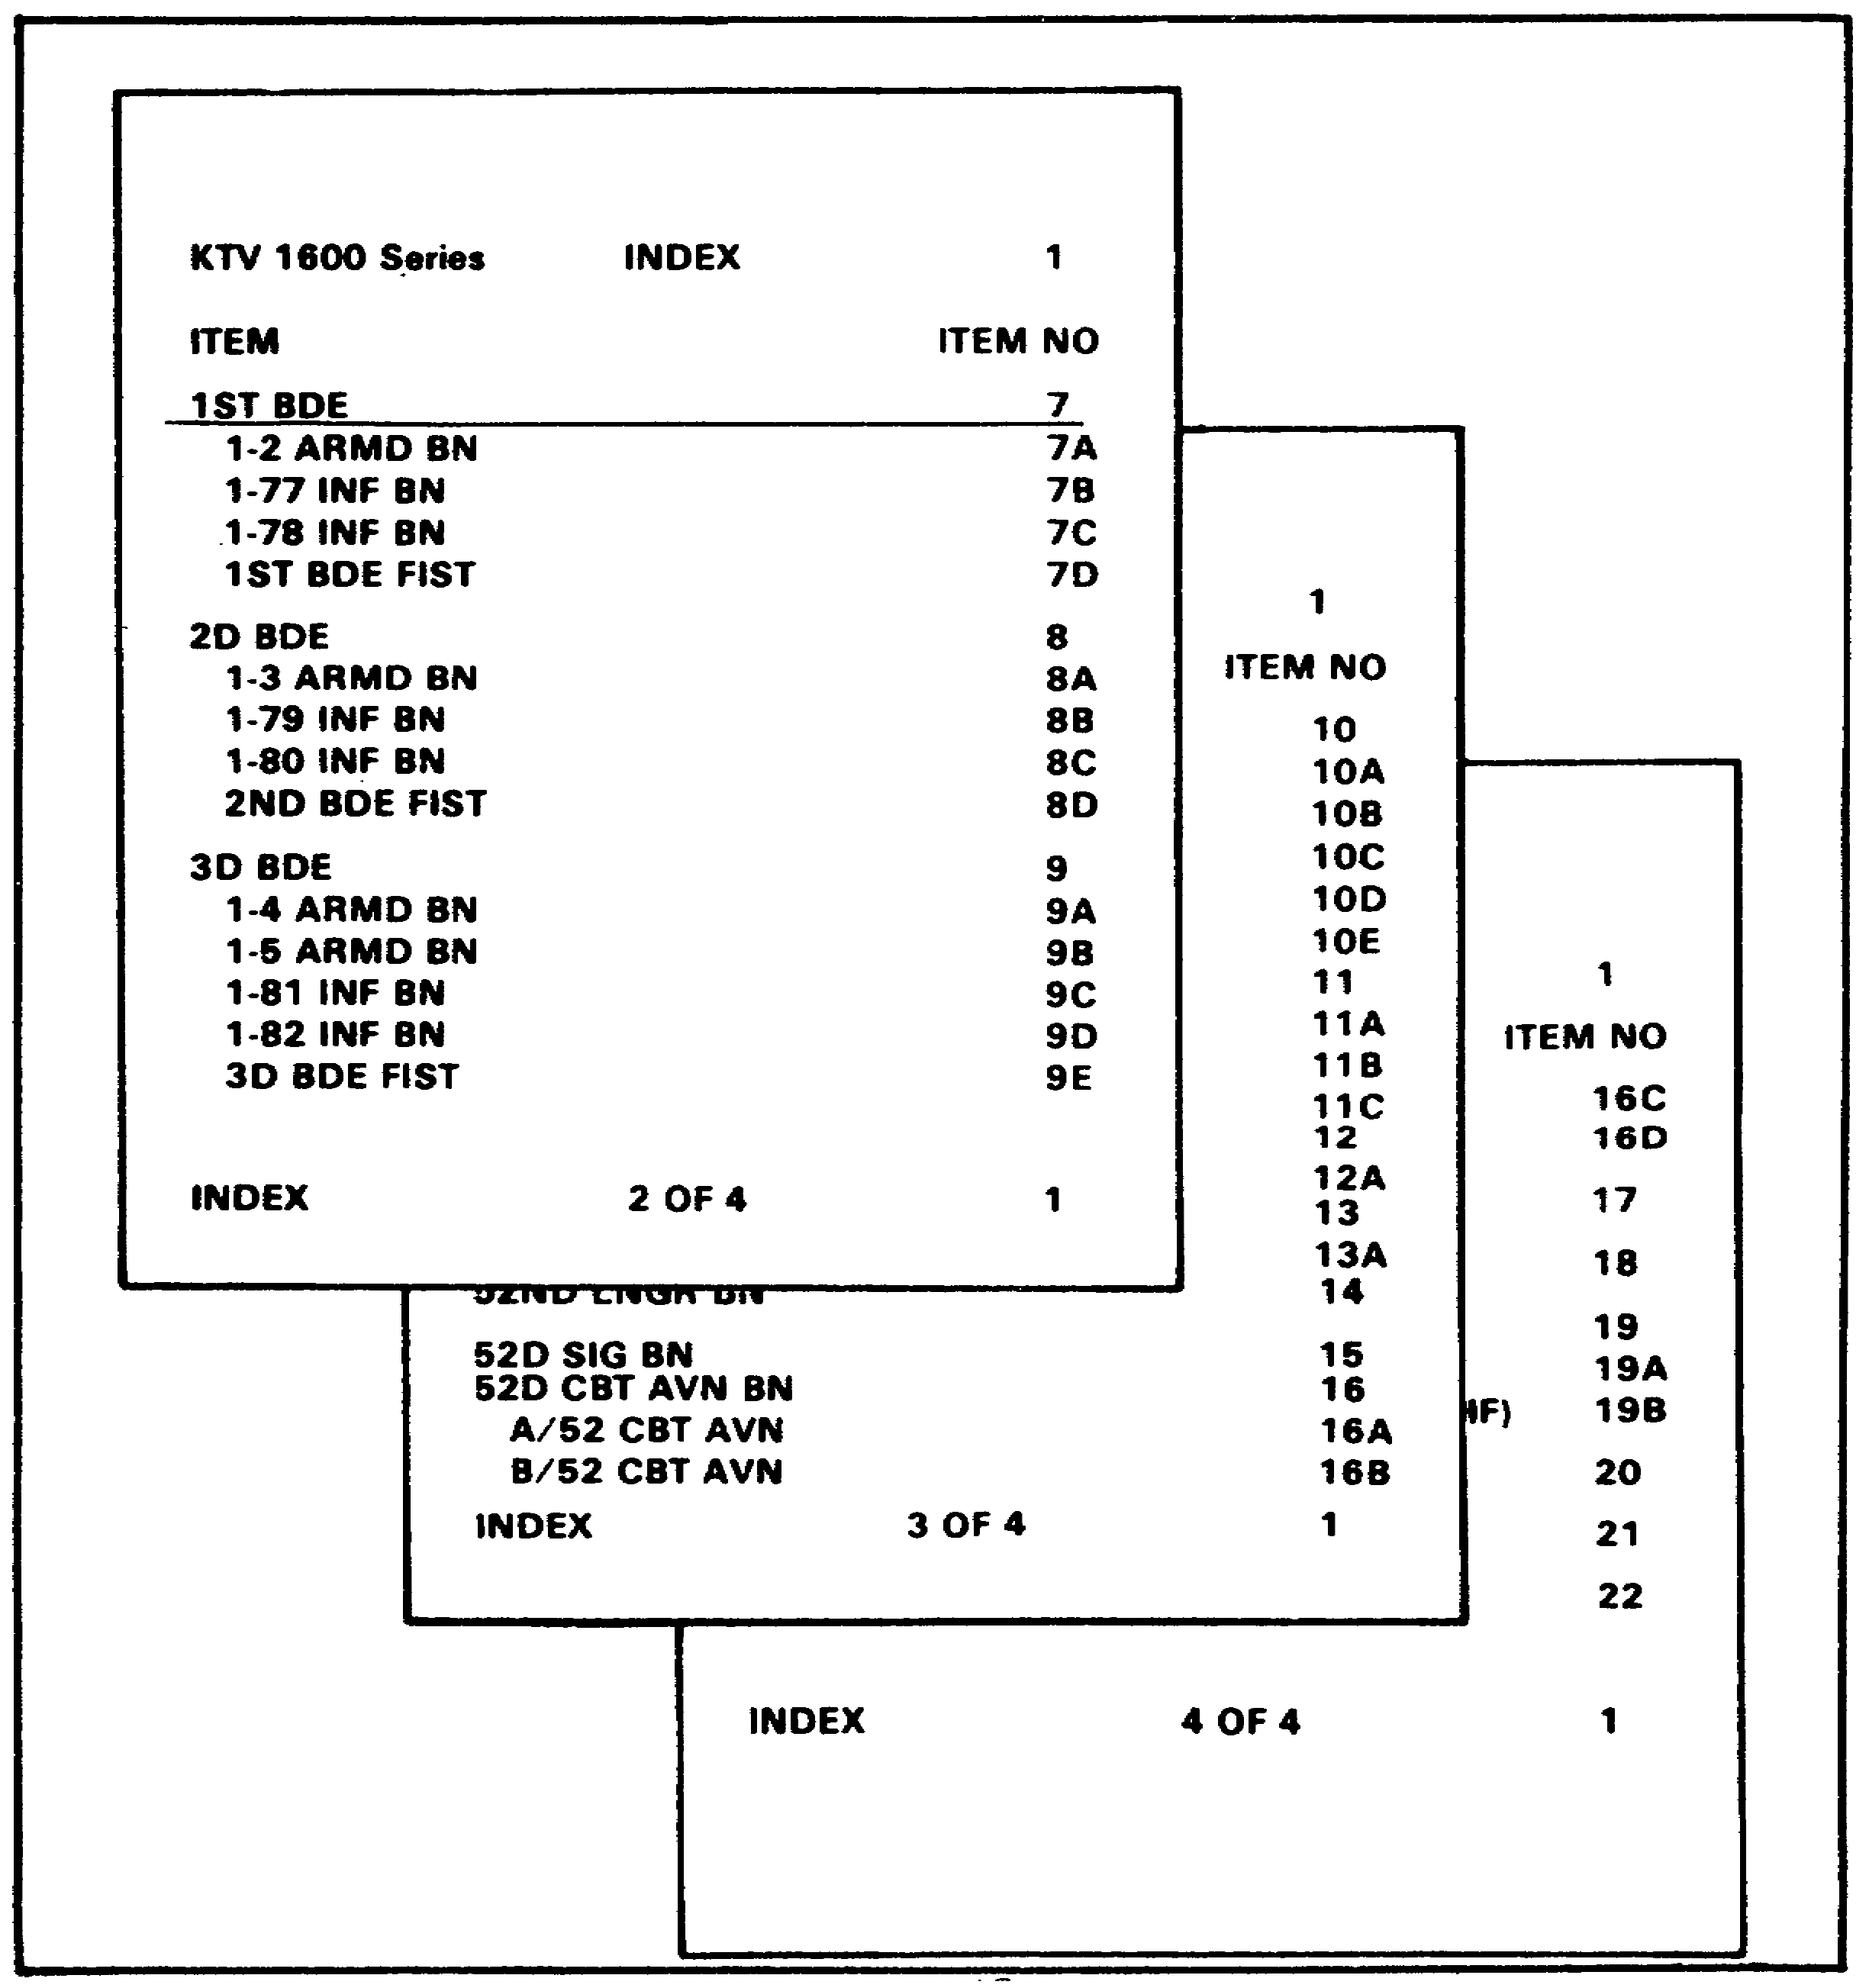

Figure 1-5. SOI Index.

5
8. The non-changing data items are numbered beginning with 101 which, like the changing data, is the index. Figure 1-6 is an example of an index page for the supplemental instructions.

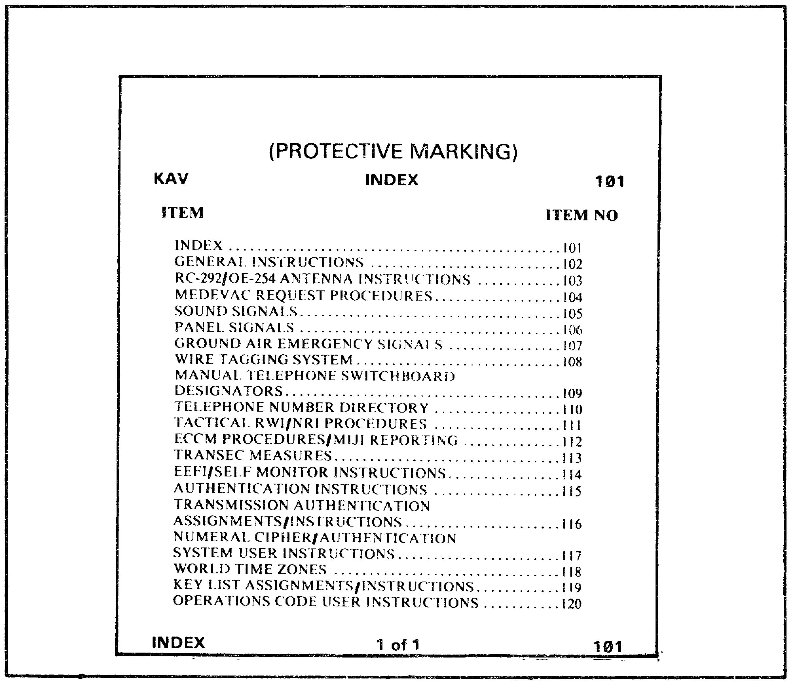
Figure 1-6. Supplemental Instructions Index.

6

Learning Event 2:
LOCATE THE CORRECT SOI PAGES FOR USE

1. Before you can determine the correct page in the SOI for use, you must know your mission. For this lesson, you will be supporting the 1-77 Infantry Battalion 51 with non-secure FM communications. You will be operating in the 1st Brigade command net during time period one.

2. Ensure that your operators know what the item number for the 1-77 Inf Bn is by checking the SOI index. Using Figure 1-5, we find that the item number is 7B. In order to gain the proper information to use while operating, we must locate all pages under item number 7B in the SOI.

3. Item numbers appear in the upper and lower right hand corners of the SOI page for easy reference. Additionally, the page title associated with the item appears at the top and bottom left of each page. Figure 1-2 is a single page extract for the 1-77 Inf Bn. Notice that the item number 7B is found in the upper and lower right hand corners in the block with the black background. The page title is found in the upper and lower left corners. Single page extracts remain in effect for no more than 24 hours. The specific time period covered by the extract is shown at the top center of the page. The page in Figure 1-2 is to be used during time period one.

4. Knowing that we have selected the correct SOI page for use, we can now move to extract the necessary information to establish communications in support of our mission.

7

Lesson 1

Learning Events 1 and 2

Practice Exercise

Directions: Circle the correct answer.

1. As a COMSEC aid, the SOI is designed to provide _____________________.

a. guidance
b. technical control
c. transmission security
d. speed and simplicity

2. The heart of the communications packet is______________________.

a. supplemental instructions
b. non-changing data
c. changing data
d. single page extract

3. What unit extract is shown in Figure 1-2?

a. 1-78 INF BN
b. 1-77 INF BN
c. 1-79 INF BN
d. 1-80 INF BN

4. What segments comprise an edition of SOI?

a. changing and non-changing data
b. call sign and frequency assignments
c. index and supplemental instructions
d. single time period and quick reference

5. The letter K in position 2 of the SOI short title indicates which of the following?

a. operational material
b. cryptographic material
c. training material
d. complete SOI

8

Learning Event 3:
DETERMINE THE CALL SIGN, SUFFIX/EXPANDER, OPERATING FREQUENCY, AND
ITEM NUMBER IDENTIFIER

1. As a radio team chief, you will probably not be performing all of the tasks described in this correspondence course. However, it is important for you to remain proficient in all tasks. Additional knowledge beyond the requirements of the task will enable you to more effectively supervise and train your operators.

2. In order to operate in an operational radio net, your team must acquire specific information from the SOI. This information includes your complete call sign, operating frequency, and item number identifier.

3. The call sign configuration for all SOI is a letter-number-letter combination (L-N-L). Call signs are generally assigned along command lines, but can be assigned to specific entities or activities, such as Task Force or Medevac. Single page extracts and quick reference call sign pages are designed so that there is no last letter duplication of the call signs. This allows for the abbreviation of the call sign to the last letter plus the suffix/expander. The suffix is added to the basic call sign to effectively identify the station or individual using the call sign. The expander identifies further the individual using the call sign, for example, the assistant or driver.

4. Each call sign page (quick reference) and single page extract has listed on it the elements that normally operate in one or more of the radio nets listed on the single page extract or frequency page (quick reference). At the top of each column of call sign assignments is a number (1 thru 10). This number equates to the time period during which the call sign is to be used. The established rate of change is at least every 24 hours. Simultaneous change of call signs, frequencies, and suffixes/expanders at the specified time is essential to the proper employment of the system.

5. To identify your call sign for a specific time period on a quick reference page, locate your unit in the left hand column. After finding your unit, follow the line to the right to the column corresponding with the time period. Figure 1-3 illustrates finding the call sign for 1st Brigade for time period 1. Determining your call sign from a single page extract is accomplished in the same manner.

6. Frequencies are assigned to nets, not units or individuals. These frequencies change simultaneously with call sign assignments. Determining your operating frequency is accomplished using the exact same steps as determining your call sign. Figure 1-3 shows the frequency for the 1st Brigade command net for time period 1.

9

7. As stated previously, suffixes/expanders aid in the further identification of stations and individuals in a radio net. Figure 1-7 is an example of a suffix master list. The assigned suffix for each station/position/individual changes at the same time as do the call signs and frequencies. The suffixes appearing on the single page extract are identical to those appearing on the master list.

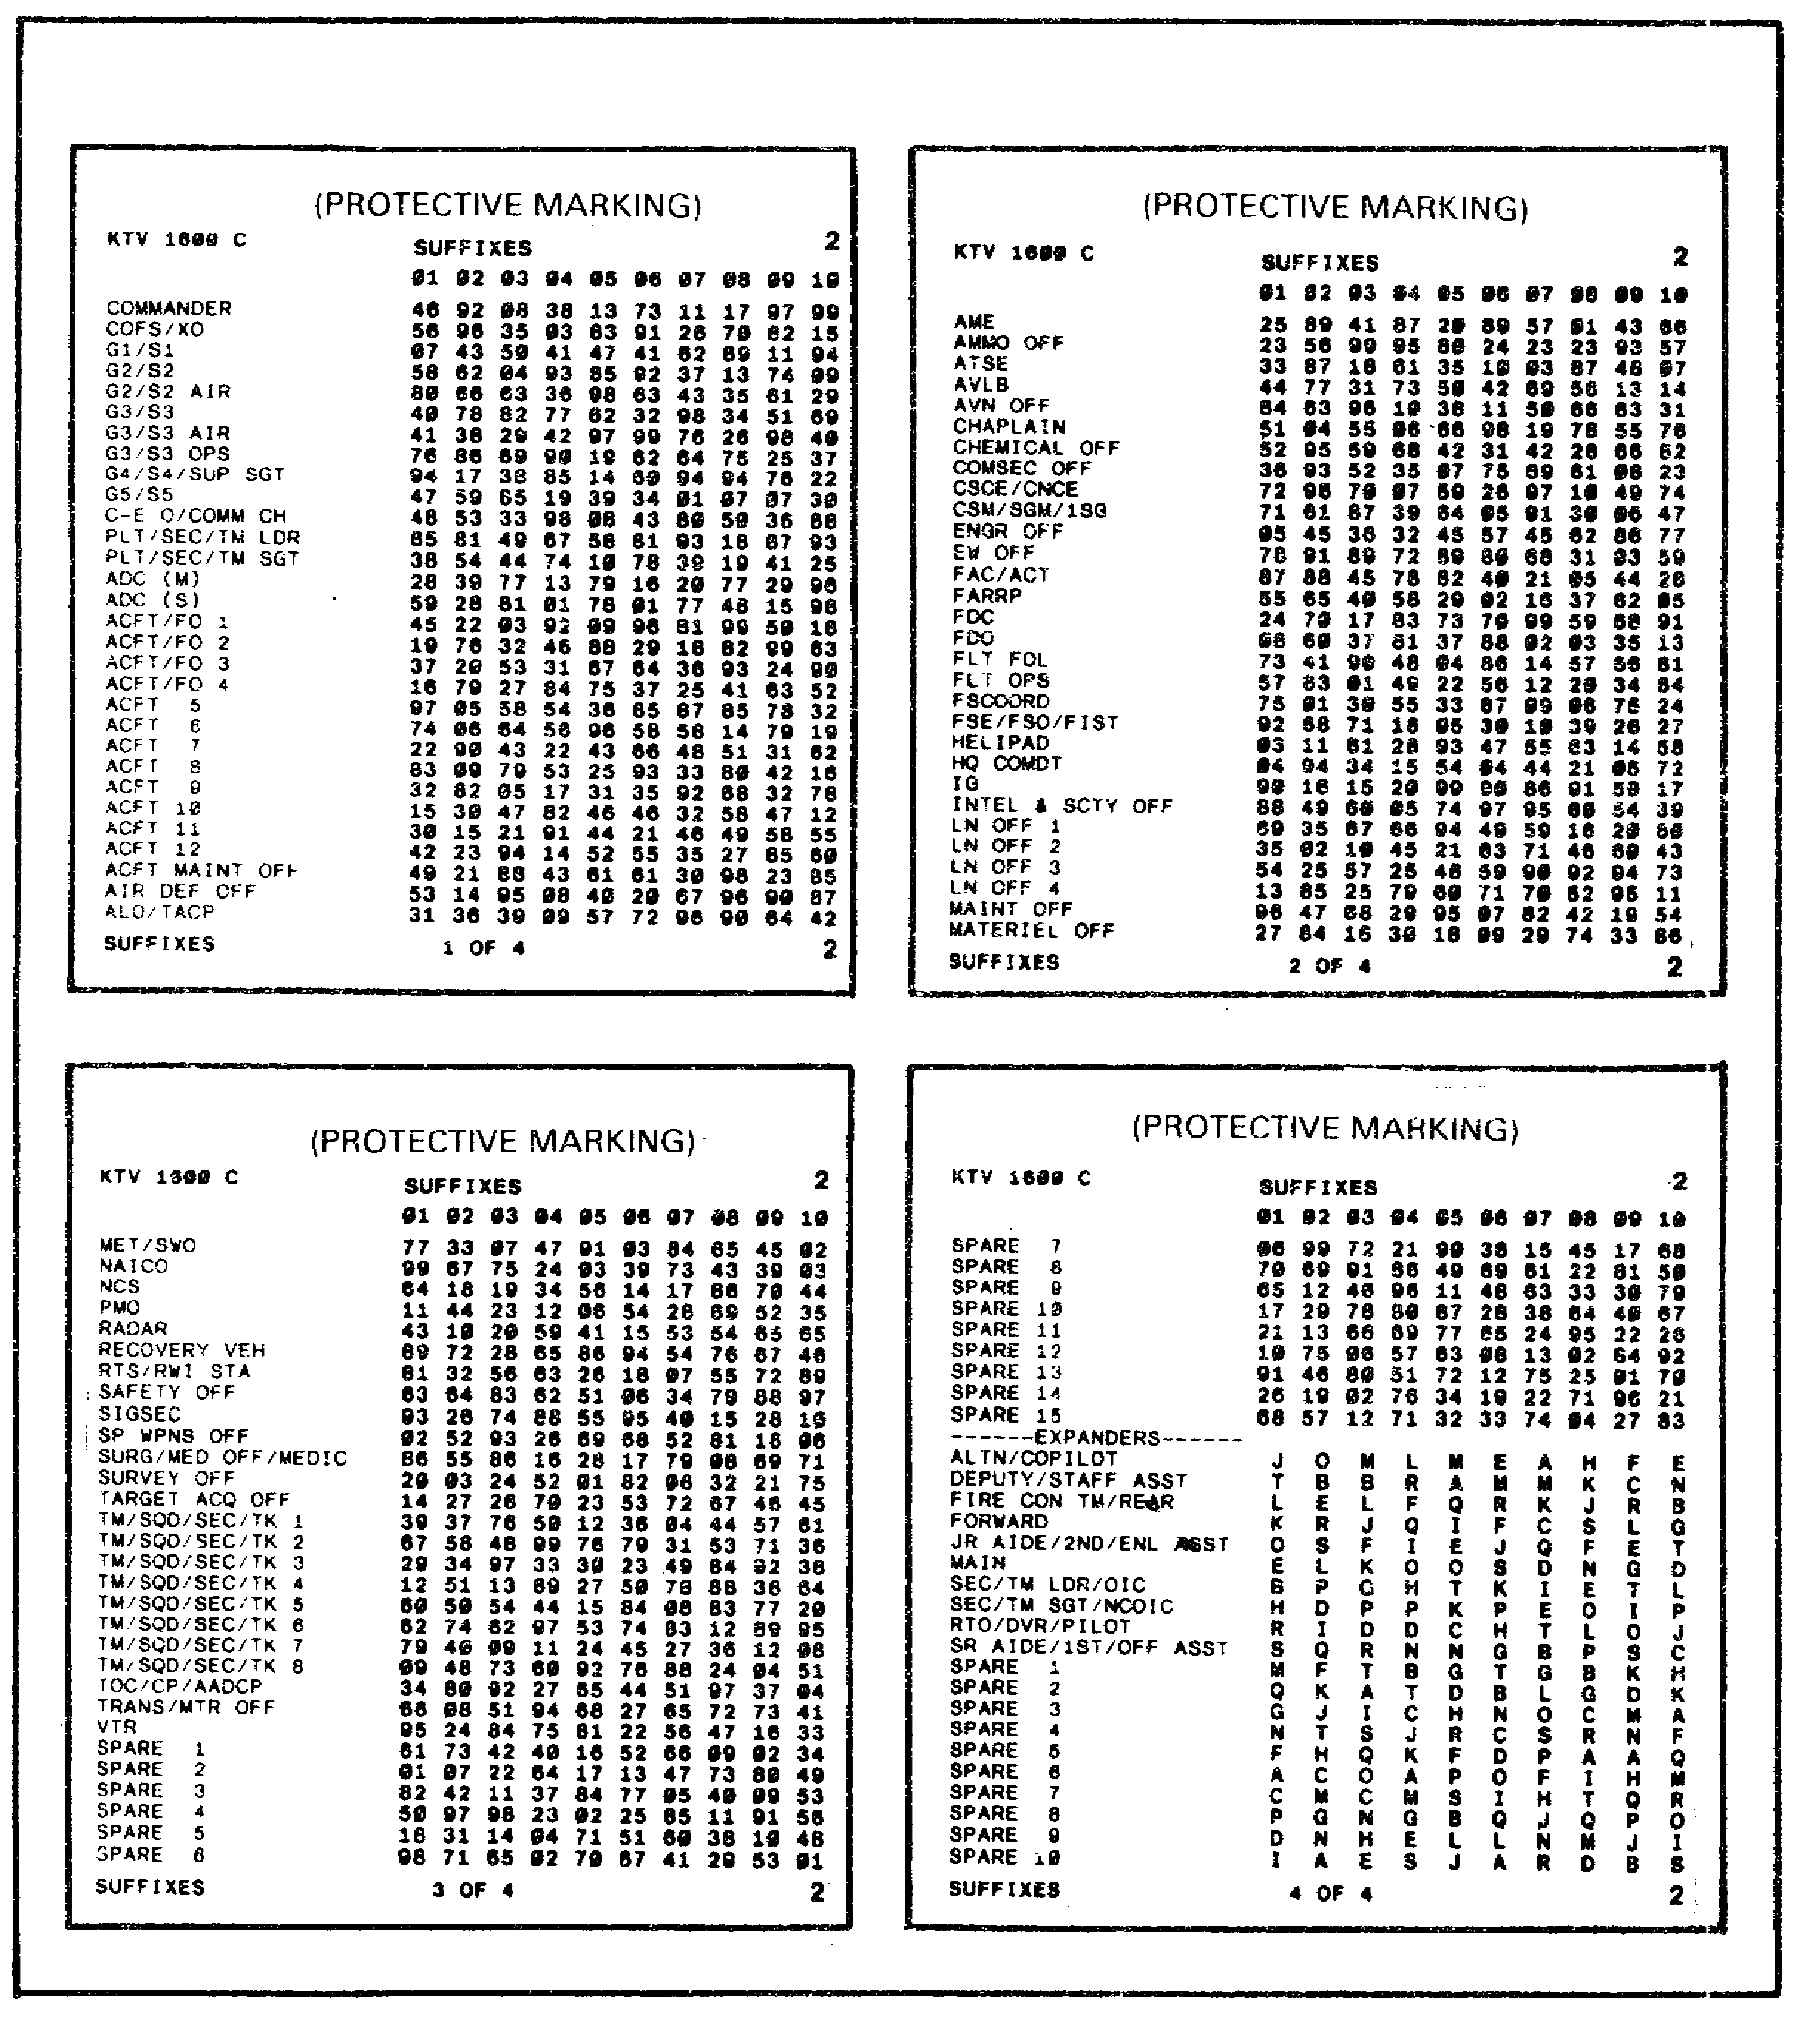

Figure 1-7. Call Sign Suffixes

10

8. Regardless of the net we operate in, the same call sign is used for all operations during a specific time period. At times, it may be necessary to operate in a net in which we do not normally operate. For these instances, an item number identifier (INI) has been included in the SOI. The purpose of the INI is to enable the NCS of an unfamiliar net to quickly identify an unknown station. Figure 1-8 is a list of item number identifiers. Item number identifiers change at the same time as does other data in the SOI (every 24 hours). This is why you see 10 columns of INI in Figure 1-8. Looking at Figure 1-8, we see the INI for the 1st Brigade has been circled for time periods 1, 2, and 3. The INI for particular unit is determined by locating the item number from the SOI in the column corresponding to the operational time period. From this point, follow that line to the left hand column. This column consists of a list of two-letter combinations or diagraphs. The diagraphs begin with AA and continue in sequence equal to the number of call signs and frequency items in the index. As shown in Figure 1-8, the INI for 1st Brigades, time period 1, is AE. By following the same steps, we find the INI for 1-77 INF BN to be BJ.

11

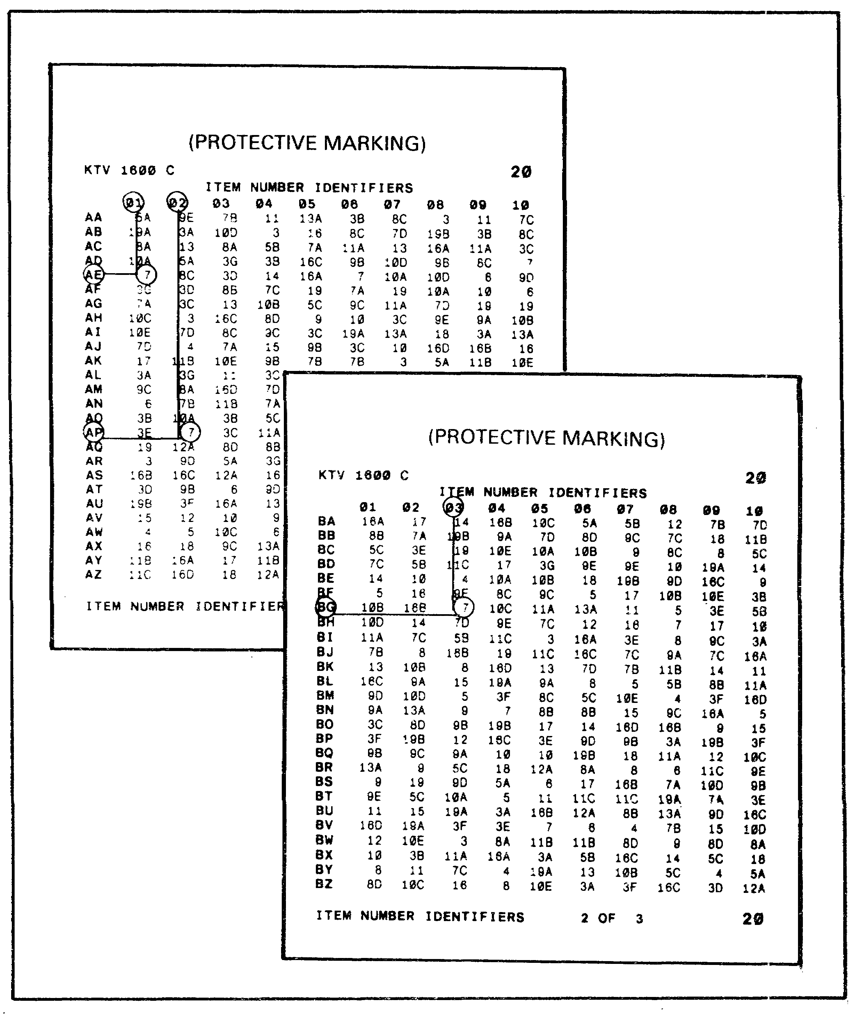

Figure 1-8. Item Number Identifiers.

12

9. When attempting to enter a net you do not normally operate in, the NCS will challenge your station to provide identification. At this time, you will transmit your INI diagraph to the NCS. By referring to the INI page in the SOI and then to the index, the NCS will be able to identify your unit. Although the INI system is similar to authentication, the two systems should not be confused. The INI system serves only to provide identification, not authentication.

10. During this learning event, we have acquired the information from the SOI necessary to operate in a radio net. Using this information, we can now establish communications in our assigned net. Securing those communications is essential, and it is the responsibility of the radio team to ensure that the enemy is denied access. The next learning event will provide information on the steps taken to provide that security.

Learning Event 4:
IDENTIFY THE CORRECT AUTHENTICATION TABLE IN EFFECT AND DEMONSTRATE PROPER USE

1. Item 115 of the supplemental SOI instructions contains standard instructions for the use of authorized authentication systems. Authentication remains the best method for protecting a communications or command system against fraudulent transmission or simulation (deception). Properly used authentication systems provide a means of validating a calling station.

2. The two authorized authentication systems are challenge and reply authentication, and transmission authentication. Challenge and reply authentication is the preferred method and should be used whenever possible.

3. The KTC 1400 (*) is the training equivalent used for both types of authentication. The numeral cipher table is used for the challenge and reply authentication, while the table of two-letter combinations on the reverse side is used for transmission authentication. Identifying the correct table for use is accomplished by selecting the appropriate set and period. Authentication tables are issued in blocks of 10 sets (days). The blocks of 10 sets are 1-10, 11-20, 21-31, with two periods per set. Set 1 is used on the 1st day of the month, set 11 on the 11th day of the month, and so on with the set corresponding to the day of the month. Each set consists of two periods. Period 1 is used from 2400 hrs to 1159 hrs, while period 2 is used from 1200 hrs to 2359 hrs. The changes are to be made according to local time.

13

4. As it is the preferred method, challenge and reply authentication will be used whenever possible. The advantage of using challenge and reply authentication is that both parties can be validated. The calling party is validated by the called party by responding to a two-letter challenge. In turn, the party responding then challenges and receives a response from the other party. A correct response to a challenge validates the calling party. Do not accept a challenge as an authentication. The practice of challenge and reply authentication prevents enemy operators from entering a net to obtain correct authentication responses for use in other nets.

14

5. To accomplish challenge and reply authentication, any two-letter combination is selected (except Z). As shown in Figure 1-9, the challenge formed is FC. The correct reply is found by locating the first letter (F) of the challenge in the left (line indicator) column of the table. Following that line to the right, locate the second letter (C) of the challenge. The letter directly below the second letter of the challenge is the correct response (B) to the challenge. Example 2 in Figure 1-9 illustrates replying to a challenge beginning with the letter Y, which requires you to go to the A line to find the appropriate reply. In the case of example 2, the correct response to the challenge YY, is B. On occasion a station may incorrectly reply to an authentication challenge. In such instances, the challenging station will issue a new challenge to ensure that the station is authentic. Additionally, an unusual delay in responding to a challenge would require a new challenge to be issued.

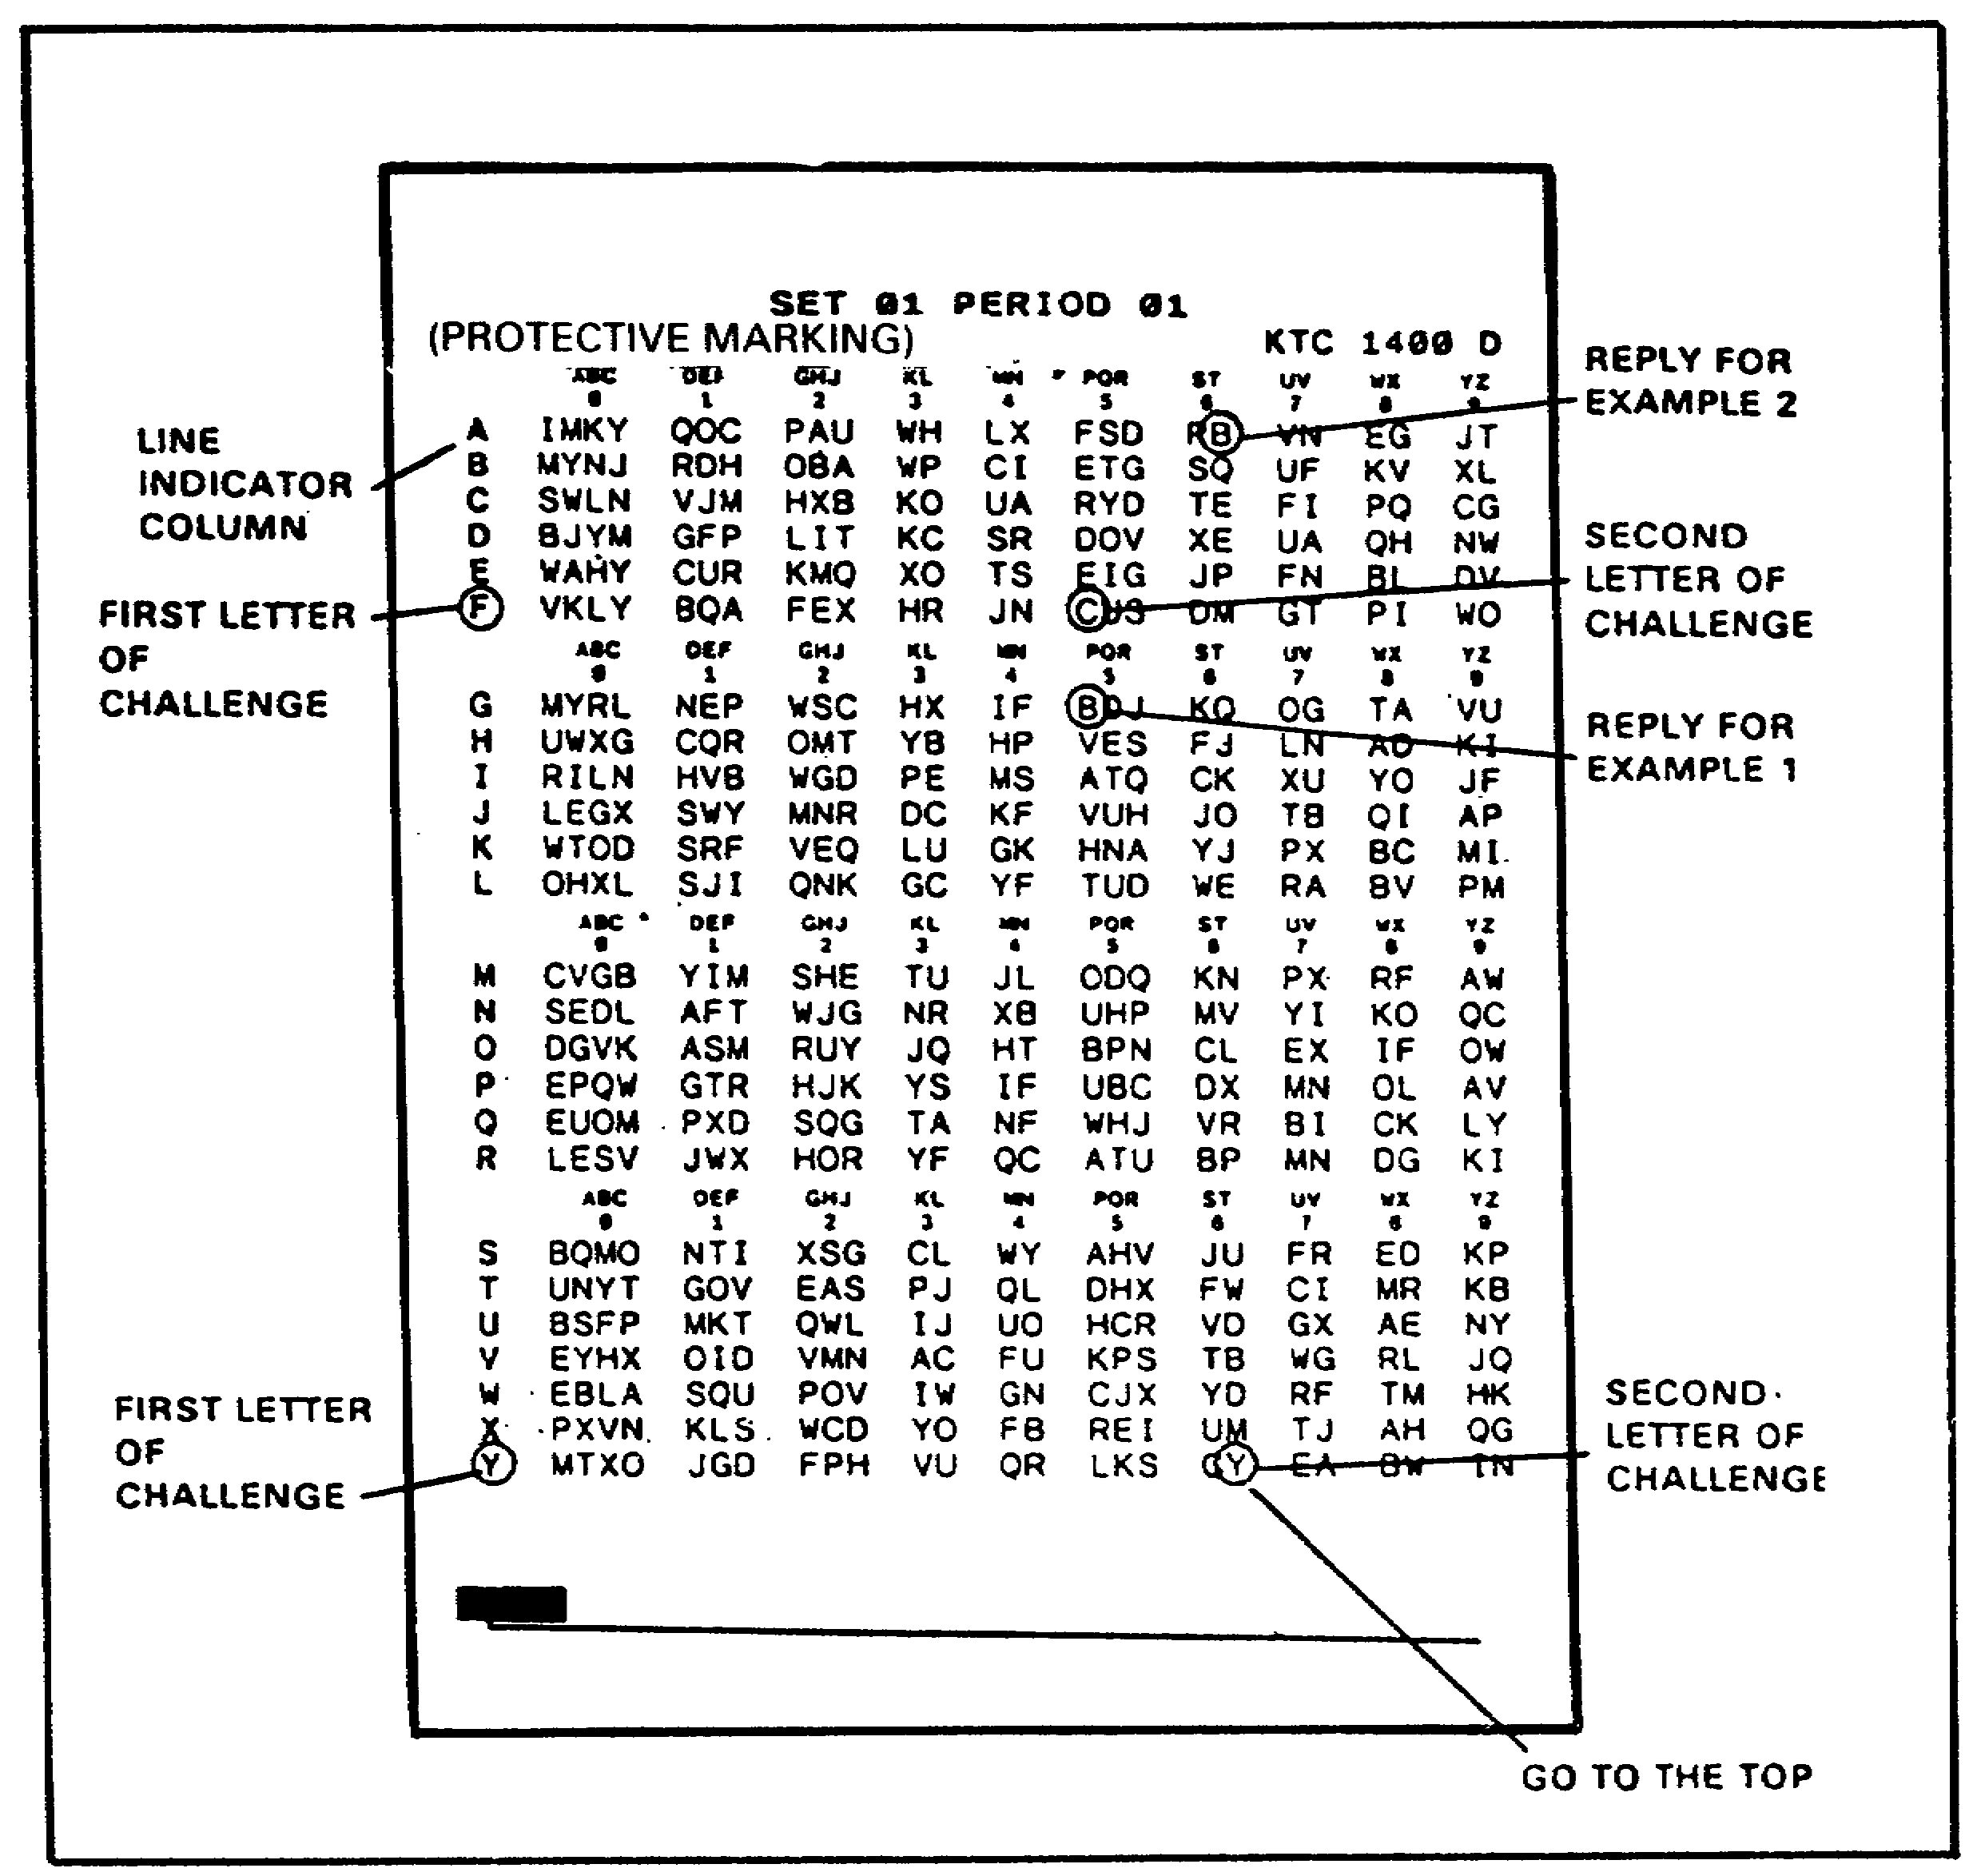

Figure 1-9. KTC 1400 D.

15
6. The table for use in transmission authentication is found on the reverse of the numeral cipher table. The supplemental SOI instructions item 116 assigns specific columns for use by units using the SOI. Each column contains a list of two-letter authenticators. As an authenticator is used, it is crossed out to preclude its further use. When transmission authentication is to be used, the first available two-letter authenticator is transmitted. If you were assigned column 1, in Figure 1-10, your first available authenticator would be HZ. After transmitting, you would cross out the authenticator, and use VX the next time transmission authentication is required. Transmission authentication will be used only in situations where authentication is required and it is not possible or desirable for the receiving station to reply. Examples would include directing radio silence, sending a message in the blind, or in an emergency.

7. As a radio team supervisor, it is imperative that you train your team members to use authentication systems properly. Supervision of the use of authentication will help to ensure that your communications system is protected from enemy deception. Failure to secure communications can result in the enemy intruding into your net, passing erroneous information, and disrupting communications.

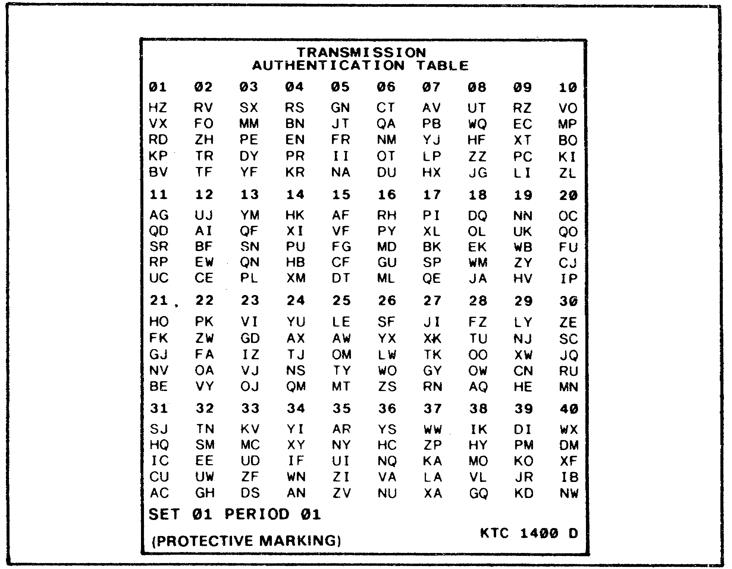

Figure 1-10. Transmission Authentication Table.

16
Lesson 1

Learning Events 3 and 4

Practice Exercise

SITUATION: Your team has been tasked to provide non-secure FM voice communications for the S3, 1-77 INF BN in the 1st Brigade command net.

Refer to Figure 1-11 on the next page.

1. What is your call sign (L-N-L) for period 8?

a. J1V
b. D4H
c. N2B
d. I0T

2. What is your operating frequency for period 8?

a. 56.10 MHz
b. 42.60 MHz
c. 75.80 MHz
d. 33.30 MHz

17

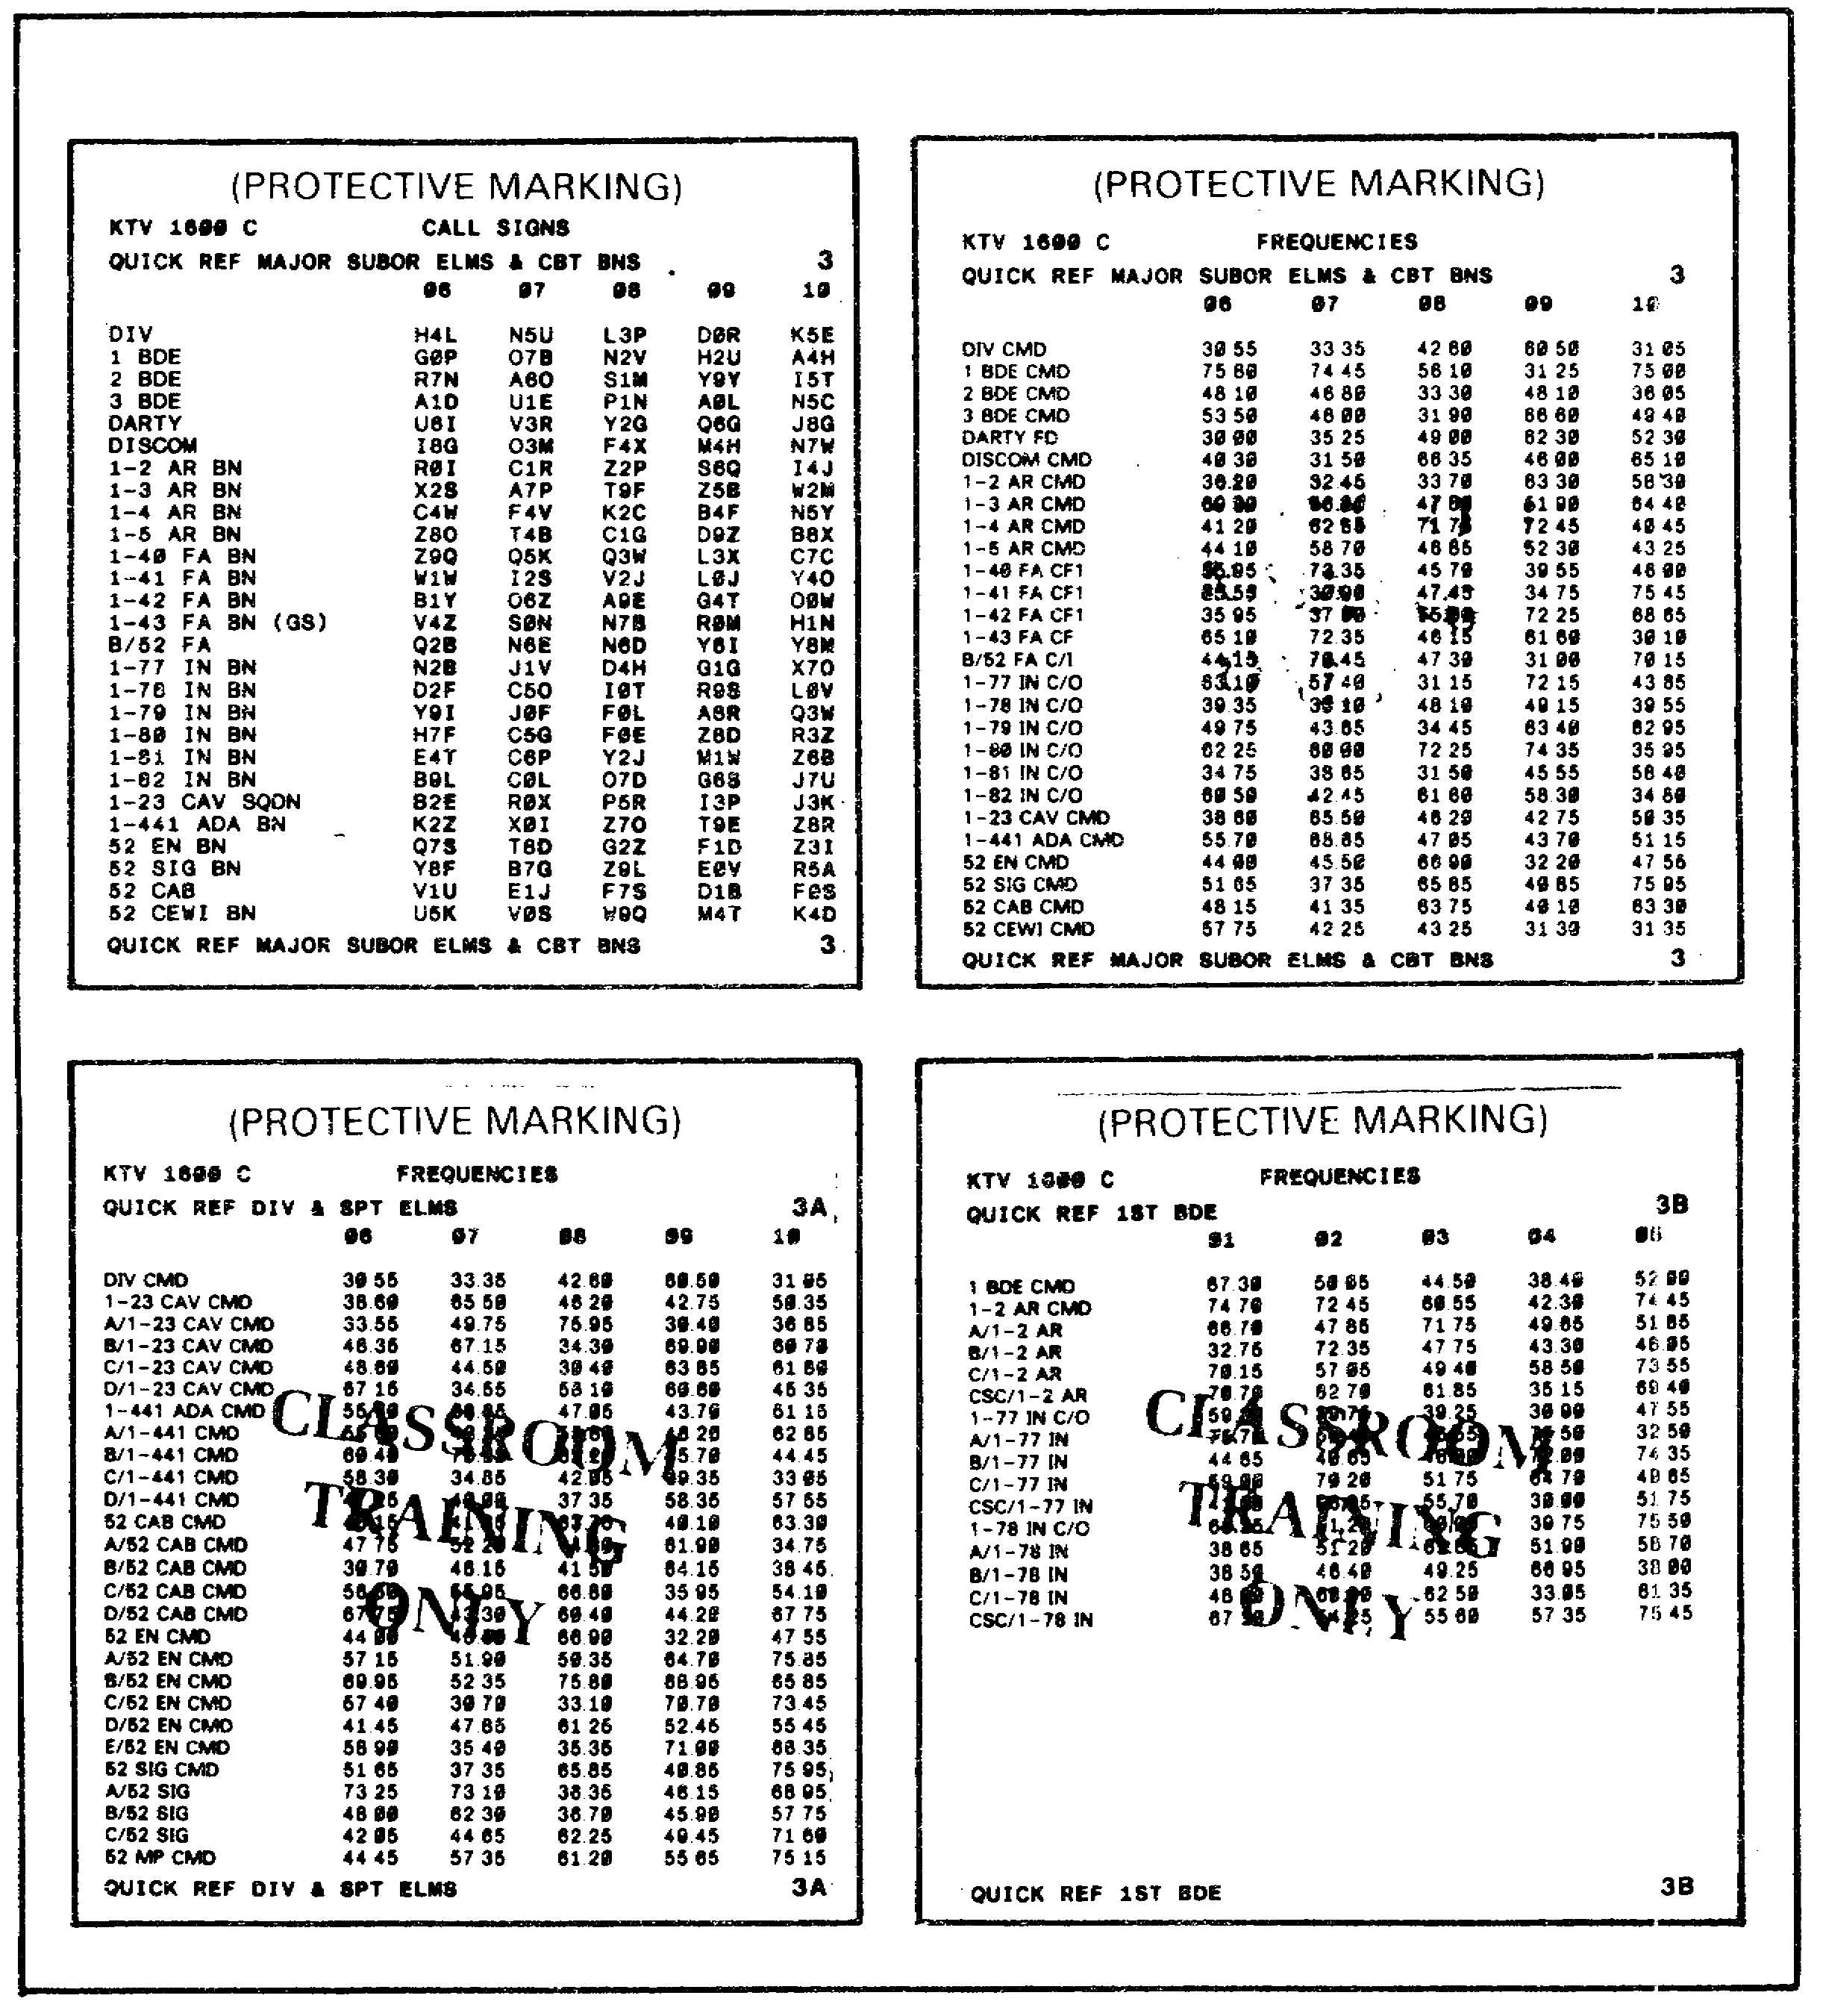

Figure 1-11. Quick Reference Items.

18
Refer to Figure 1-12 below.

3. What suffix and expander will your operators use for period 8?

a. 26L
b. 34P
c. 75P
d. 34L

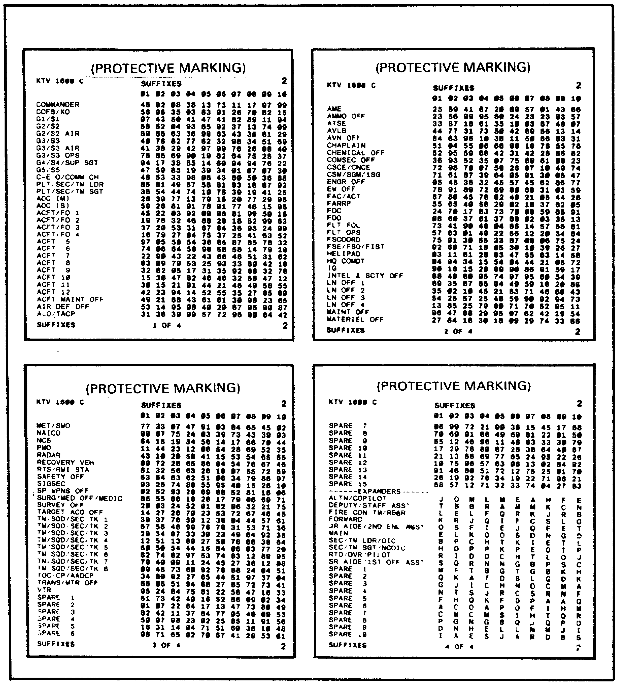

Figure 1-12. Item Number Identifiers.

19
Refer to Figure 1-13 on the next page.

4. Your item number is 7B. What is your item number identifier for period 8?

a. BH
b. BB
c. BV
d. AG

5. What set/period of authentication tables would you use on April 8 at 2100 hours?

a. set 8/period 1
b. set 8/period 2
c. set 18/period 1
d. set 18/period 2

20

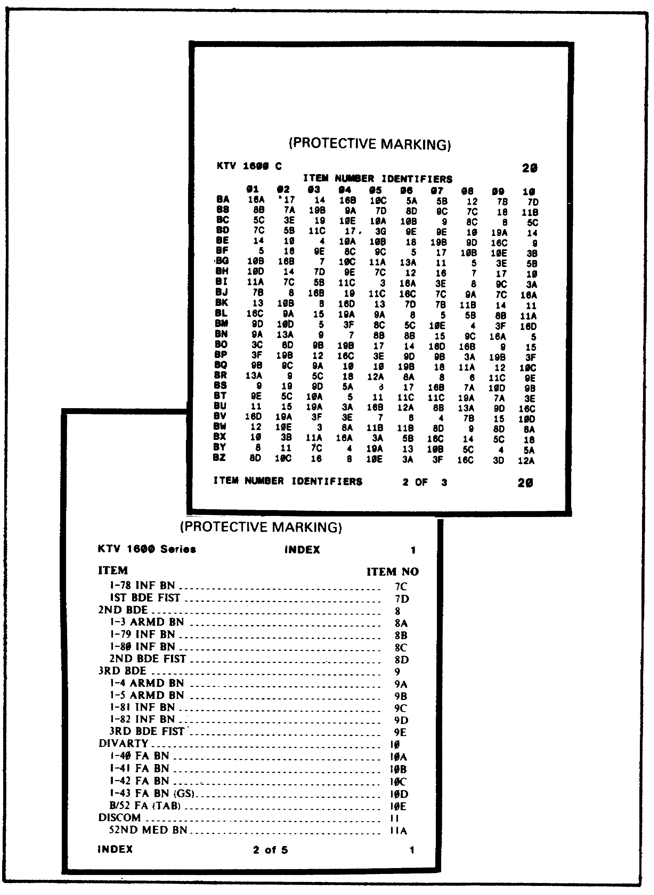

Figure 1-13. Item Number Identifiers.

21
Lesson 1

Supervise Radio Team's Use of SOI

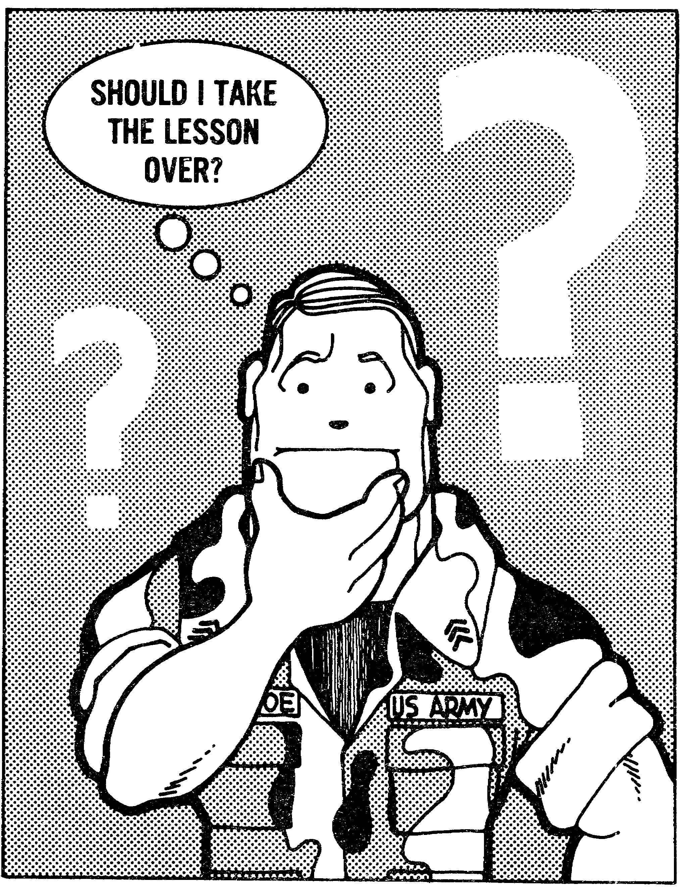

22

LESSON 2
SUPERVISE RADIO TEAM'S USE OF
PROPER PROCEDURES TO ENTER,
OPERATE IN, AND LEAVE A RADIO NET

TASK

Supervise radio team's use of proper procedures to enter, operate in, and leave a radio net.

CONDITIONS

Given changing and non-changing SOI data, a net assignment, and extracts from ACP 125(*) with US Supplement 1 and TC 24-19.

STANDARDS

Identify the proper procedures for entering, operating in, and leaving a radio net IAW ACP 125(*) with US Supplement 1 and TC 24-19 by correctly responding to 70% of the multiple-choice test.

REFERENCES

Extracts of ACP 125(*) with US Supplement 1
Extract of TC 24-19.

Learning Event 1:
IDENTIFY THE PROPER PROCEDURES TO ENTER A RADIO NET

1. Radiotelephone procedures are used in all military communications. These established procedures provided guidance for the opening of, operation in, and closing of radio nets. The strict adherence to these procedures by all operators is mandatory. Any departures or variations from the established procedures can create confusion, reduce reliability, and nullify security precautions.

2. A radio net is an organization of stations capable of direct communication on a common frequency. In a free net those stations may communicate with each other without obtaining prior permission from the NCS. Operation of a directed net indicates the need for stricter control of traffic flow by the NCS. This need arises from factors that may include a large net, a large volume of traffic, or a requirement for stricter discipline. Prior permission must be obtained from the NCS to transmit in a directed net.

23

3. While operating in a radio net, the following types of call signs and calls are used:

a. Individual call sign - identifies a single station.

b. Collective call sign - identifies a predetermined group of stations.

c. Net call sign - identifies all stations in a net.

d. Single call - one call sign precedes the proword/prosign, "THIS IS/DE".

e. Multiple call - two or more call signs precede the prosign/proword, "THIS IS/DE".

4. Procedures for establishing a net will be used when opening a net for the first time or reopening a net. At a designated time, or when ready to establish the net, the NCS will make a call to the net. The NCS will use the net call sign to identify all stations in the net. The net call will be answered by the subordinate stations in alphanumeric order of their abbreviated call signs. All predetermined stations of a collective call sign will answer a collective call in the same manner as a net call. The abbreviated call signs will be used during the net opening process
and at all times except the following:

a. When entering a net in which you do not normally operate.

b. When so instructed by the NCS.

Example: A request to transmit complete call signs when readability is difficult and positive identification is necessary.

24

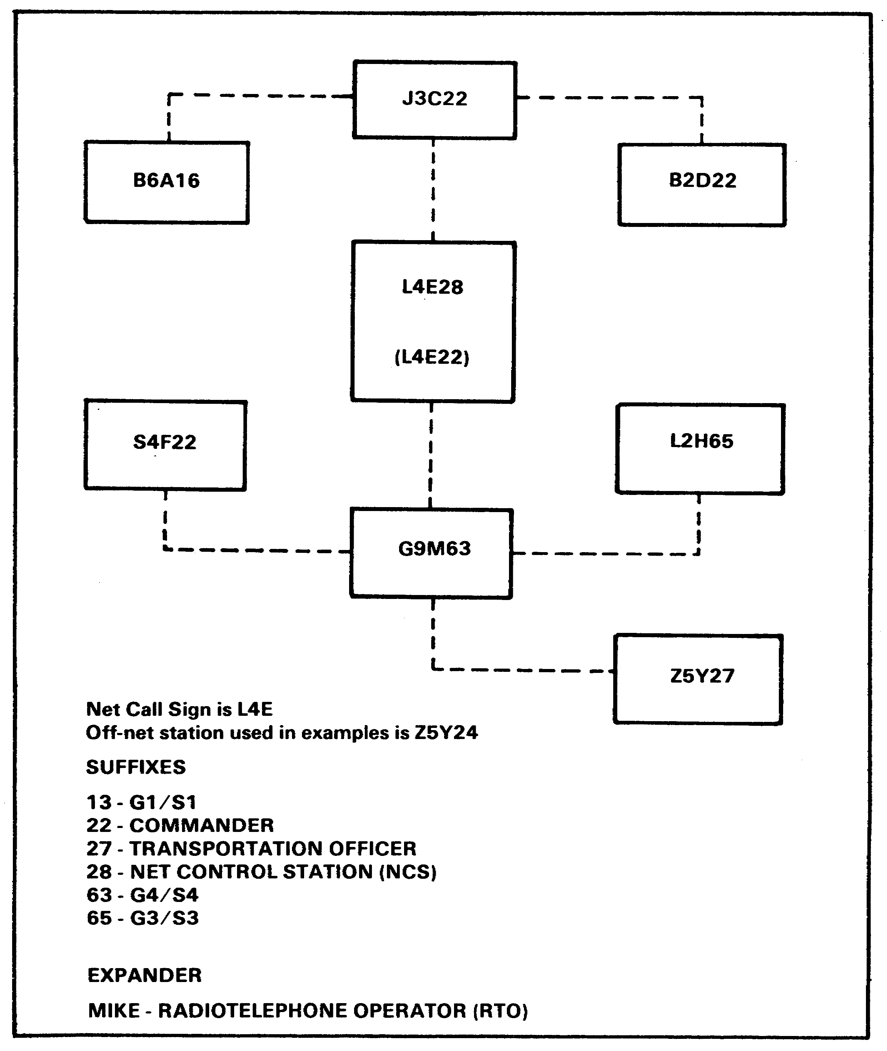

Figure 2-1. Net Diagram.

25
5. Figure 2-1 is an example of the organization of a common radio net. The call signs used in Figure 2-1 and the examples that follow are derived from a typical ground unit SOI and are used to standarize the examples. Within the examples, prosing meanings will be written as they are spoken to maintain clarity.

EXAMPLE A: Opening a radio net.

NOTE: Authentication is optional in a SECURE net.

At a designated time or when ready to open the net, the NCS transmits:

Lima Four Echo - THIS IS Echo Two Eight - AUTHENTICATE Foxtrot Golf - OVER

The opening process continues as shown below.

Echo Two Eight - THIS IS Alfa One Six Mike - I AUTHENTICATE Charlie - AUTHENTICATE - Tango Uniform - OVER

Lima Four Echo - THIS IS Echo Two Eight - I AUTHENTICATE Juliett - AUTHENTICATE Hotel Bravo - OVER

Lima Four Echo - THIS IS Charlie Two Two Mike - I AUTHENTICATE Victor - AUTHENTICATE Sierra Lima - OVER

Lima Four Echo - THIS IS Foxtrot Two Two Mike - I AUTHENTICATE
Alfa - AUTHENTICATE Bravo Echo - OVER

Lima Four Echo - THIS IS Hotel Six Five Mike - I AUTHENTICATE Romeo - AUTHENTICATE Victor Zulu - OVER

Lima Four Echo - THIS IS Mike Six Three Mike - I AUTHENTICATE Delta - OVER

The NCS now calls the net to inform all stations that their transmissions have been heard and has no traffic for them.

Lima Four Echo - THIS IS Echo Two Eight - OUT

Notice in this example that the NCS did not challenge each substation. The NCS challenged the net, and was challenged by the first substation. Each substation, with the exception of the first substation, directed the call to the net call sign. Regardless of the order of reply, each station is replying to the net call. The transmission includes a reply to a challenge and a new challenge.

26
6. Not all nets will be established with the same ease as shown in Example A. Many times one or more stations will fail to or be unable to answer the net call. In these situations the next station in alphanumeric order will wait five seconds and then transmit. The station which fails to answer in proper order must wait until all other stations have answered or had an opportunity to answer. Example B demonstrates the procedures to follow in these situations.

EXAMPLE B:

In this example, the subordinate station S4F22M is unable to answer the net call. After receiving answers from all stations except S4F22M, L4E28 then would transmit:

Lima Four Echo - THIS IS Echo Two Eight - ROGER - Foxtrot Two Two Mike - NOTHING HEARD - OUT

S4F22M, when able to transmit, calls the NCS to report into the net:

Echo Two Eight - THIS IS Foxtrot Two Two Mike - REPORTING INTO THE NET - OVER

L4E28, having no traffic for S4F22M, transmits:

Foxtrot Two Two Mike - THIS IS Echo Two Eight - AUTHENTICATE - Victor Delta - OVER

Echo Two Eight - THIS IS Foxtrot Two Two Mike - I AUTHENTICATE Alfa - OVER

Foxtrot Two Two Mike - THIS IS Echo Two Eight - ROGER - OUT

After the NCS has acknowledged the stations that answered the net call, and transmits NOTHING HEARD to the stations failing to answer, those stations may enter the net.

27
Lesson 2

Learning Event 1

PRACTICE EXERCISE

Direction: Circle the correct answer.

1. Following prescribed radiotelephone procedures is____________.

a. recommended
b. a security violation
c. mandatory
d. optional

2. A transmission using a net call sign is an example of a(n) _________________.

a. individual call sign
b. multiple call
c. collective call sign
d. single call

3. Substations reply to a net call ___________________________.

a. immediately after receiving the call
b. in alphanumeric order of their abbreviated call signs
c. in the order units are listed in the SOI
d. when they wish to enter the net.

4. Complete call signs are used________________________________.

a. when directed by the NCS
b. anytime you enter a net
c. when transmitting a message
d. at all times

5. When opening a net, the NCS will ______________________________.

a. use his complete call sign
b. make a net call
c. call each substation
d. all of the above

28
Learning Event 2:
IDENTIFY THE PROPER PROCEDURES TO TRANSMIT AND RECEIVE TRAFFIC
WITHIN A RADIO NET

1. The primary function of a radio net is to provide a means for exchanging information. Proper procedures need to be followed at all times to ensure that security is maintained.

2. Authentication must be used during net establishment in a non-secure net, and is optional in a secure net. Authentication will be used when directing a frequency change (does not include scheduled changes) following the procedures in Example C.

EXAMPLE C:

The NCS changes the net to a new frequency using the designator B11:

Lima Four Echo - THIS IS Echo Two Eight - Change to frequency Bravo One One - (Time) - OVER

Echo Two Eight - THIS IS Alfa One Six - AUTHENTICATE Whiskey Gulf - OVER

Lima Four Echo - THIS IS Echo Two Eight - I AUTHENTICATE Tango - OVER

Echo Two Eight - THIS IS Alfa One Six - ROGER - OUT

29
Echo Two Eight - THIS IS Charlie Two Two - ROGER - OUT

Echo Two Eight - THIS IS Delta Two Two - ROGER - OUT

This procedure continues until all stations have responded.

Some other situations require the use of authentication, and they will be covered individually later in this lesson.

3. When operating in a radio net, the number and length of transmissions should be kept to a minimum. Abbreviated procedures are acceptable when communications are good and no confusion will result. In particular, the call sign of the station called may be omitted when a call is part of an exchange of transmissions between two stations. For speed of working on large nets, the proword THIS IS may be omitted by the receiving station when responding to a call or receipting for a transmission. When two stations are in continuous communications with each other on a net not shared by a third station, the call may be omitted entirely. For ground forces use, this provision may apply to any two stations within the same net that are in continuous communications with each other. When communication reception is very good, message parts need to be transmitted only once, preliminary calls are optional, and most prowords may be eliminated. Additionally, the drafter of a message should eliminate all words not essential to the meaning of the message. An abbreviated exchange is demonstrated in Example D.

Example D: Abbreviated Transmissions

L4E22 transmits:

Mike Six Three - Echo Two Two

G9M63 having heard the break after the word Two, transmits:

Mike Six Three

L4E22 having heard the break after the word Three, transmits:

Move to Bravo Zulu

G9M63 having heard the break after the word Zulu, transmits:

Authenticate Papa Alfa

L4E22 having heard the break after the word Alfa, transmits:

Tango

G9M63 having heard the break after the word Tango, transmits:

WILCO - OUT

30
4. Under normal conditions, message parts need to be transmitted only once, and preliminary calls are optional. At times, communications conditions can be difficult at best. During these times, words, groups, or phrases may be transmitted twice and preliminary calls should be used. The proword WORDS TWICE is transmitted to indicate that all portions of the message or transmission will be repeated. Example E illustrates this procedure.

EXAMPLE E: WORDS TWICE

S4F22 transmits:

Alfa One Six - Alfa One Six - THIS IS Foxtrot Two Two - Foxtrot Two Two - PRIORITY - OVER

B6A16 transmits:

Foxtrot Two Two - Foxtrot Two Two - THIS IS Alfa One Six - Alfa One Six - SEND YOUR MESSAGE - OVER

S4F22 transmits:

Alfa One Six - Alfa One Six - THIS IS Foxtrot Two Two - Foxtrot Two Two - WORDS TWICE - WORDS TWICE - PRIORITY - PRIORITY - (BREAK) - Convoy has arrived - Convoy has arrived - (BREAK) - TIME One Six Three Zero Zulu - TIME One Six Three Zero Zulu - OVER

B6A16 transmits:

Foxtrot Two Two - Foxtrot Two Two - THIS IS Alfa One Six - Alfa One Six - SAY AGAIN SAY AGAIN - WORD BEFORE has - WORD BEFORE has - OVER

S4F22 transmits:

Alfa One Six - Alfa One Six - THIS IS Foxtrot Two Two - Foxtrot Two Two - I SAY AGAIN I SAY AGAIN - WORD BEFORE has - WORD BEFORE has - Convoy - Convoy - OVER

B6A16 transmits:

Foxtrot Two Two - Foxtrot Two Two - THIS IS Alfa One Six - Alfa One Six - ROGER OUT

5. Radio checks are commonly used when one station wishes to inform another of its signal strength and readability. Radio checks should not be exchanged unless one station cannot hear another clearly. Scheduled or too frequent radio checks undermine transmission security and should be avoided.

31
The prowords listed below are for use when initiating and answering queries concerning signal strength and readability:

(1) General

RADIO CHECK What is my signal strength and readability?

ROGER I have received your last transmission satisfactorily. The omission of comment on strength and readability is understood to mean that reception is loud and clear. If reception is other than loud and clear, it must be described with the prowords from subparagraphs (2) and (3).

NOTHING HEARD To be used when no reply is received from a called station.

(2) Report of Signal Strength

LOUD Your signal is very strong.

GOOD Your signal strength is good.

WEAK Your signal strength is weak.

VERY WEAK Your signal strength is very weak.

FADING At times your signal strength fades to such an extent that continuous reception cannot be relied upon.

(3) Report of Readability

CLEAR Excellent quality

READABLE Quality is satisfactory.

UNREADABLE The quality of your transmission is so bad that I cannot read you.

DISTORTED Having trouble reading you because your signal is distorted.

WITHIN INTERFERENCE Having trouble reading you due to interference.

INTERMITTENT Having trouble reading you because your signal is intermittent.

32
The procedures in Example F are established for the use of radio checks. Radio checks, as with other transmissions, should be limited to use only when absolutely necessary.

EXAMPLE F: RADIO CHECKS

L4E28 (NCS) desires a radio check with L4E (NET).

Lima Four Echo - THIS IS Echo Two Eight - RADIO CHECK - OVER

All stations of the net call hear L4E28 loud and clear except J3C22M and B2D22M. The replies of each station, in alphanumeric order are:

(THIS IS) Alfa One Six Mike - ROGER - OVER

(THIS IS) Charlie Two Two Mike - WEAK BUT READABLE - OVER

(THIS IS) Delta Two Two Mike - WEAK WITH INTERFERENCE - OVER

(THIS IS) Foxtrot Two Two Mike - ROGER - OVER

(THIS IS) Hotel Six Five Mike - ROGER - OVER

(THIS IS) Mike Six Three Mike - ROGER - OVER

L4E28 indicates the reception of each of the called stations as loud and clear, except for J3C22M, who was distorted and B2D22M who was not heard, by replying:

(Lima Four Echo) - (THIS IS) Echo Two Eight - ROGER - Charlie Two Two Mike DISTORTED - Delta Two Two Mike NOTHING HEARD - OUT

6. When communications is difficult or when the calling station wishes to ascertain whether the station called is ready to receive a message, a preliminary call will be sent before transmitting a message. When operating in a directed net, prior permission must be obtained from the NCS before making a preliminary call. In Examples G and H, the use of preliminary calls is demonstrated.

EXAMPLE G: PRELIMINARY CALLS

J3C22M wishes to transmit a message to S4F22M and desires to know if S4F22M is ready to accept it. J3C22M transmits:

Foxtrot Two Two Mike - THIS IS Charlie Two Two Mike - MESSAGE - OVER

S4F22M, ready to accept the message, transmits:

Charlie Two Two Mike - THIS IS Foxtrot Two Two Mike - Send your MESSAGE - OVER

33
J3C22M transmits:

Foxtrot Two Two Mike - THIS IS Charlie Two Two Mike - MESSAGE ROUTINE; etc.

EXAMPLE H: PRELIMINARY CALLS

B2D22M wishes to transmit a message L2H65M and desires to know that L2H65M is ready to accept it.

B2D22M transmits:

Hotel Six Five Mike - THIS IS Delta Two Two Mike - PRIORITY - OVER

L2H65M, not prepared to accept the traffic immediately, transmits:

Delta Two Two Mike - THIS IS Hotel Six Five Mike - WAIT - After a short pause, L2H65M is ready and transmits:

Send your PRIORITY - OVER

NOTE: If the L2H65M delay had been longer than a few seconds, L2H65M would have transmitted:

Delta Two Two Mike - THIS IS Hotel Six Five Mike - WAIT - OUT

When ready to accept the message, L2H65M would transmit:

Delta Two Two Mike - THIS IS Hotel Six Five Mike - Send your PRIORITY - OVER

7. The transmission and reception of messages is the means by which units and their communications support personnel exchange information. Instructions for the preparation and handling of specific types of messages are found in AR 105-31. Your responsibility as a radio team chief is to ensure that proper procedures for the preparation and handling of messages are followed, and to ensure proper procedures are followed in the transmission and reception of those messages. The procedures outlined in paragraphs 3 and 4 of this learning event, illustrating the proper procedures for sending and receiving transmissions under good and difficult communications conditions, also apply to the transmission and reception of messages. In addition to those procedures, the paragraphs following address procedures particular to messages.

8. At times when communications conditions are difficult or when the information contained in a message may be easily misunderstood, an operator may request that the receiving operator read back the entire text or a portion of it. In these situations, the proword READ BACK is transmitted with the identifying data immediately after the call. Example I demonstrates two possible situations.

34
EXAMPLE I: READ BACK

(1) L4E28 transmits:

Mike Six Three Mike - THIS IS Echo Two Eight - READ BACK - (BREAK) - Convoy has arrived - (BREAK) - TIME One Six Three Zero Zulu - OVER

G9M63M transmits:

(THIS IS) Mike Six Three Mike - I READ BACK - Mike Six Three Mike - THIS IS Echo Two Eight - READ BACK - (BREAK) - Convoy has arrived - (BREAK) - TIME One Six Three Zero Zulu - OVER

L4E28 Transmits:

(THIS IS) Echo two Eight - CORRECT - OUT

(2) J3C22 transmits:

Delta Two Two - THIS IS Charlie Two Two - READ BACK Grid - Meet me grid One Three Four Two Six Five - OVER

B2D22 transmits:

(THIS IS) Delta Two Two - I READ BACK grid One Three four Two Six Five - OVER

J3C22 transmits:

(THIS IS) Charlie Two Two - CORRECT - OUT

NOTE: When READ BACK procedure is employed, the proword ROGER is not necessary to indicate receipt of the message.

The proword READ BACK when not preceded by identifying call signs means that all stations are to READ BACK. If a collective call sign is used but only part of the stations represented in the call are required to read back, the station(s) will be specified by transmitting the appropriate call signs preceding the proword READ BACK. When the order to READ BACK is given, only those stations directed to do so will READ BACK; remaining stations called will keep silent unless directed by the calling station to receipt.

EXAMPLE J: READ BACK

L4E28 transmits:

Lima Four Echo - THIS IS Echo Two Eight - Delta Two Two READ BACK - Convoy has arrived - TIME One Six Three Zero Zulu - OVER

35
B2D22 transmits:

THIS IS Delta Two Two - I READ BACK - Lima Four Echo - THIS IS Echo Two Eight - Delta Two Two READ BACK - Convoy has arrived - TIME One six Three Zero Zulu - OVER

L4E28 transmits and directs J3C22 to RECEIPT:

THIS IS Echo Two Eight - CORRECT - C22 - OVER

J3C22 transmits:

THIS IS Charlie Two Two - ROGER - OUT

NOTE: If B2D22, in Example J, had read back incorrectly, L4E28 would have called attention to the error by use of the proword WRONG followed by the correct version.

EXAMPLE K: READ BACK

B2D22 transmits:

THIS IS Delta Two Two - I READ BACK - Lima Four Echo - THIS IS Echo Two Eight - Delta Two Two - READ BACK - Convoy has arrived - OVER

L4E28 transmits:

THIS IS Echo Two eight - WRONG - TIME One Six Three Zero Zulu - OVER

B2D22 transmits:

THIS IS Delta Two Two - TIME One Six Three Zero Zulu - OVER

L4E28 transmits:

THIS IS Echo Two Eight - CORRECT - OUT

9. When it is imperative that called stations do not answer a transmission, the proword DO NOT ANSWER will be transmitted immediately following the call and the complete transmission will be sent twice. The full transmission will end with the proword OUT, and include transmission authentication. An illustration is given in Example L.

36
EXAMPLE L: DO NOT ANSWER

L4E28 transmits:

Lima Four Echo - THIS IS Echo Two Eight - DO NOT ANSWER - (BREAK) - Act in accordance with plan Charlie - (BREAK - TIME Two Two One Eight Zulu - AUTHENTICATION IS Foxtrot Alfa I SAY AGAIN - Lima Four Echo - THIS IS Echo Two Eight - DO NOT ANSWER - (BREAK) - Act in accordance with plan Charlie - (BREAK) - TIME Two Two One Eight Zulu - AUTHENTICATION IS Foxtrot Alfa - (BREAK) - OUT

10. Some situations will dictate that a message be relayed by a receiving station to other stations within a radio net. For these situations, the prowords RELAY and RELAY TO will be used. The proword RELAY used alone indicates that the station called is to relay the message to all addressees.

L4E28 transmits: (to an on-net station.)

Alfa One Six Mike - THIS IS Echo Two Eight - RELAY - PRIORITY - TIME One One One Three Two Two Zulu - FROM Echo Two Eight - TO Hotel Six Five - (BREAK) - Proceed on mission assigned - (BREAK) - OVER

B6A16M transmits:

(THIS IS) Alfa One Six Mike - ROGER - OUT

B6A16M relays the message:

Hotel Six Five Mike - THIS IS Alfa One Six Mike PRIORITY TIME One One One Three Two Two Zulu - FROM Echo Two Eight - TO Hotel Six Five - (BREAK) - Proceed on mission assigned - (BREAK) - OVER

L2H65M transmits:

(THIS IS) Hotel Six Five Mike - ROGER - OUT

The proword RELAY TO followed by an address designator, indicates that the station called is to relay the message to the stations indicated. When one or more stations is called, the call sign of the station designated to perform the relay will precede the proword RELAY TO. At times it is necessary to relay a message originated on a radiotelephone circuit by some other means of communications. When such relay is necessary, it is the responsibility of the station relaying the message to place the message in the proper format for the means of communications employed for relay. Complete call signs must be used in the address component of the message being relayed outside the net.

37

EXAMPLE M: RELAY TO (to an off-net station).

J3C22M transmits:

Mike Six Three Mike - Delta Two Two Mike - THIS IS Charlie Two Two Mike - Mike Six Three RELAY to Zulu Five Yankee Two Seven Mike - ROUTINE - TIME Two One Zero Eight One Four Zulu - FROM Juliett Three Charlie Two Two - TO Zulu Five Yankee Two Seven - INFO Golf Niner Mike Six Three - Bravo Two Delta Two Two - (BREAK) - Text - (BREAK) - OVER

G9M63M transmits:

(THIS IS) Mike Six Three Mike - ROGER - OUT

B2D22M transmits:

(THIS IS) Delta Two Two Mike - ROGER - OUT

G9M63M relays the message to Z5Y27M:

Zulu Five Yankee Two Seven Mike - THIS IS Golf Niner Mike Six Three Mike - ROUTINE - TIME Two One Zero Eight One Four Zulu - FROM Juliett Three Charlie Two Two - TO Zulu Five Yankee Two Seven - INFO Golf Niner Mike Six Three - Bravo Two Delta Two Two - (BREAK) - Text - (BREAK) - OVER

Z5Y27M transmits:

(THIS IS) Zulu Five Yankee Two Seven Mike - ROGER - OUT

11. When words are missed or doubtful when receiving a message, repetitions will be requested by stations before receipting for the message. The proword SAY AGAIN used in conjunction with ALL BEFORE ____ , ALL AFTER ____, ____ TO ____, WORD BEFORE ____ , or WORD AFTER ____ , will be use ed for this purpose. In complying with requests for repetitions, the transmitting station will identify that portion which is being repeated.

EXAMPLE N: REPETITION

L4E28 calls the two stations for which there is traffic:

Charlie Two Two - Delta Two Two - THIS IS Echo Two Eight - MESSAGE - ROUTINE - TIME - Zero Eight One Zero Five Two Zulu - FROM Echo Two Two - To Charlie Two Two - INFO Delta Two Two (BREAK) - At One Eight Zero Zero Zulu - Proceed Hong Kong - To arrive One Six May - Load One Thousand Troops - For return to Ningpo - I SPELL - November India November Golf Papa Oscar - Ningpo - Acknowledge - (BREAK) - OVER

38

J3D22 having missed from AT to Proceed transmits:

(THIS IS) Charlie Two Two - SAY AGAIN At TO Proceed - OVER

L4E28 deals with the request for repetition by J3C22, before the other station requests repetitions:

THIS IS Echo Two Eight - I SAY AGAIN - At TO Proceed - At One Eight Zero Zero Zulu Proceed - OVER

J3C22 having now received the message satisfactorily, transmits:

(THIS IS) Charlie Two Two - ROGER - OUT

Having heard J3C22 give a receipt for the message, the next station asks for repetitions. In this case B2D22 missed from At to Proceed and the word after Load. As J3C22 already asked for the phrase At to Proceed and B2D22 heard it repeated, it isn't necessary to request that part which was repeated. B2D22 therefore, asks for the word after Load to be repeated.

In requesting repetitions of the heading of a message, a repetition may be requested for all that portion of the heading preceding or following a proword. Also, a repetition may be requested for that portion of the heading between any two prowords. Requests for repetitions and replies must include the nearest proword preceding and/or following the portion requested.

When it is necessary to ask for repetitions after a message has been receipted, such request and replies must identify the message being queried as well as the portion being requested. Where used, the date-time group or time group shall be used to identify the message.

12. When an error is made by the transmitting operator, the proword CORRECTION will be transmitted. The last word, group, proword, or phrase correctly transmitted will follow the proword CORRECTION. Transmission of the message will then continue.

EXAMPLE 0: CORRECTIONS DURING TRANSMISSION.

G9M63M transmits:

Hotel Six Five Mike - THIS IS Mike Six Three Mike - (BREAK) - Convoy Romeo Three - CORRECTION - Romeo Four should arrive - One Six Three Zero Zulu - (BREAK) - TIME One Zero One Two Zulu - OVER

L2H65M transmits:

(THIS IS) Hotel Six Five Mike - ROGER- OUT

39

On occasion, an error may not be discovered immediately. In these cases, a correction may be made in the final instruction element, provided that the ending sign has not been transmitted. When making such a correction, the word, group, proword, or phrase must be properly identified.

EXAMPLE P:

B2D22M transmits:

Hotel Six Five Mike - THIS IS Delta Two Two Mike - (BREAK) - Tanks will arrive - Grid Three Two One Nine Five Three at Hotel Hour Minus six - (BREAK) - TIME One Four Two Six Zulu - CORRECTION - WORD AFTER Minus - Five - OVER

L2H65M transmits:

(THIS IS) Hotel Six Five Mike - ROGER OUT

If it is necessary to make corrections after a receipt has been obtained for a message, then an abbreviated service message, identifying the message and the portion to be corrected, should be made as follows:

G9M63M transmits:

Hotel Six Five Mike - THIS IS Mike Six Three Mike - CORRECTION - My One Three One Five One Six Zulu - WORD AFTER Monday - Morning - OVER

13. During the transmission of a message and prior to the transmission of the ending proword OVER or OUT, the transmission may be cancelled by use of the proword DISREGARD THIS TRANSMISSION - OUT.

EXAMPLE Q: CANCELLING TRANSMISSIONS

During the transmission of a message, S4F22M realizes that the transmission is being sent in error and therefore cancels it.

Mike Six Three Mike - THIS IS Foxtrot Two Two Mike - ROUTINE - TIME One Zero Zero Six Zero Two Zulu - (BREAK) - Begin unloading at One One One Two Three Zero Zulu - Proceed - DISREGARD THIS TRANSMISSION - OUT

A message which has been completely transmitted can only be cancelled by another message.

40

14. Receipt is employed in direct station-to-station traffic handling. No message is considered delivered until a receipt is obtained. A receipt may be effected as follows: The receiving station transmits a receipt after each message or string of messages by the proword ROGER.

EXAMPLE R: RECEIPT

J3C22M transmits:

Foxtrot Two Two Mike - THIS IS Charlie Two Two Mike - Send boat for mail - OVER

S4F22M transmits:

(THIS IS) Foxtrot Two Two Mike - ROGER - OUT

When the transmitting station considers speed of handling a primary consideration, one station in the net may be directed to receipt for the message and to other stations may answer until instructed to do so. This does not prohibit any station from requesting repetition. Security is enhanced if the same station is directed to receipt for all transmissions.

EXAMPLE S:

Station L4E28 sends a message to the net call L4E, and only desires a receipt from B2D22M.

L4E28 transmits:

Lima Four Echo - THIS IS Echo Two Eight - Send boat for mail - TIME One Two One Six Zulu - OVER

B2D22M transmits:

Echo Two Eight - THIS IS Delta Two Two Mike - ROGER - OUT

L2H65M, having missed the word mail, transmits:

Echo Two eight - THIS IS Hotel Six Five Mike - SAY AGAIN - WORD AFTER for - OVER

L4E28 transmits:

(THIS IS) Echo Two Eight - I SAY AGAIN - WORD AFTER for - mail - OVER

L2H65M transmits:

(THIS IS) Hotel Six Five Mike - ROGER OUT

41

Should either the transmitting or receiving station indicate there is additional traffic to be transmitted, then they would use the proword MORE TO FOLLOW in the message ending or the receipt.

J3C22M is transmitting a message to S4F22M, then wishes to indicate that there is more traffic for S4F22M, transmits:

Foxtrot Two Two Mike - THIS IS Charlie Two Two Mike - Text of message - MORE TO FOLLOW - OVER

THIS IS Foxtrot Two Two Mike - ROGER - OVER

15. An acknowledgement should not be confused with a reply or receipt. A prompt reply referring to the message may serve in lieu of an acknowledgement. It is the prerogative of the originator to request an ACKNOWLEDGEMENT to a message from any or all addressees of that message. If an acknowledgement is desired for a message, the request for acknowledgement normally is included in the text of that message. If the message has been transmitted, the request for acknowledgement will constitute a new message (see AR 105-31). Acknowledgements are originated only by the addressee to whom the request for acknowledgement was made.

EXAMPLE T: ACKNOWLEDGEMENT

L4E28 transmits a message to B2D22M and desires an acknowledgement:

Delta Two Two Mike - THIS IS Echo Two Eight - (BREAK) Search area Delta - Acknowledge - (BREAK) - TIME One One Two Zero Zulu - OVER

B2D22M transmits:

THIS IS Delta Two Two Mike - ROGER - OUT

B2D22M operator, having shown the message to the commanding officer, or authorized representative and having been ordered to acknowledge the message, transmits:

Echo Two Eight - THIS IS Delta Two Two Mike - Your One One Two Zero Zulu Acknowledged - TIME One One Two Five Zulu - OVER

16. When verification of a message or a portion thereof has been requested by an addressee, the originating station will verify with the originator and send the correct version. When a message originally sent to a number of addressees is queried by one station and is found to be incorrect, the corrected version must be sent to all addressees. The procedure for verification using the proword VERIFY, is demonstrated as follows:

42

L2H65M transmits:

Echo Two Eight - THIS IS Hotel six Five Mike - VERIFY your One Zero Zero Eight Zero One Zulu - ALL BEFORE BREAK - OVER

L4E28 transmits:

THIS IS Echo Two Eight - ROGER - OUT

L4E28 operator checks with the originator, establishes that the heading previously transmitted was correct, transmits:

Hotel Six Five Mike - THIS IS Echo Two Eight - I VERIFY my One Zero Zero Eight Zero One Zulu - ALL BEFORE BREAK - Hotel Six Five Mike - THIS IS Echo Two Eight - PRIORITY - TIME One Zero Zero Eight Zulu - FROM Echo Two Eight - TO Hotel Six Five - INFO Charlie Two Two - Groups One Seven - BREAK - OVER

L2H65M transmits:

THIS IS Hotel Six Five Mike - ROGER - OUT

17. Emergency silence may be imposed or lifted on a radio net only by competent authority. When an authorized authentication system is in force, a station must always authenticate a transmission which:

(1) Imposes emergency silence.
(2) Lifts emergency silence.
(3) Calls stations during a period of emergency silence.

Transmissions imposing emergency silence will be made twice through and ended with the proword OUT. Stations do not answer or receipt for such transmissions. SILENCE, spoken three times, means Cease transmission on this net immediately. silence will be maintained until lifted. When the proword SILENCE is used after a call, the stations addressed will cease all transmissions. To impose emergency silence on the net, L4E28 transmits:

Lima Four Echo - THIS IS Echo Two Eight - SILENCE SILENCE SILENCE - TIME Zero Nine One six Zulu - AUTHENTICATION IS _____ - I SAY AGAIN Lima Four Echo - THIS IS Echo Two Eight - SILENCE- SILENCE SILENCE - TIME Zero Nine One Six Zulu - AUTHENTICATION IS_____ - OUT

To lift emergency silence to all stations on the net, L4E28 transmits:

Lima Four Echo - THIS IS Echo Two Eight - SILENCE LIFTED - AUTHENTICATION IS _______, - OUT (or OVER as appropriate).

43

Learning Event 3:
IDENTIFY THE PROPER PROCEDURES FOR LEAVING A RADIO NET

1. Instructions in the operations order, unit SOP, and directives issued by the commander will dictate the time which a station will operate in a radio net. Movement from one location to another, loss of power, the directive of the commander, or one of many other situations may require a station to temporarily leave the net. Whatever the situation, if it is possible, a station will request permission from the NCS to leave a radio net. There will always be a situation where a station is unable to contact the NCS before leaving a net, but every effort will be made to ensure the NCS is aware of the status of your station. The example below illustrates the procedures to follow to request permission to leave a radio net you normally operate in.

EXAMPLE A: LEAVING A RADIO NET

B6A16 is changing location and will be unable to continue operations during the move.

Echo Two Eight - THIS IS Alfa One Six - Request permission to close down until One Five Three Zero Zulu - OVER

L4E28, receiving the request, transmits:

THIS IS Echo Two Eight - ROGER - OUT

2. When leaving a net in which you do not normally operate, it is not necessary to provide the NCS an expected time of return to the net. Authentication may be required when leaving a radio net, depending on the policy described in the local SOP, operations order, or the directive of the commander. Authentication is used when leaving a radio net to validate the calling station.

3. Operation in a radio net using proper procedures is critical to the security and efficient communications of units. The NCS is the station in a net ultimately responsible for the proper control and adherence to operating rules of the net. Lesson three will provide guidance on the duties and responsibilities of the NCS.

44

Lesson 2

Learning Events 2 and 3

PRACTICE EXERCISE

Directions: Circle the correct answer.

1. Authentication will be used during ___________.

a. scheduled frequency changes
b. radio checks
c. WORDS TWICE
d. unscheduled frequency changes

2. When communications reception is very good, message parts ___________.

a. need to be transmitted only once
b. are transmitted twice
c. are to be verified
d. are eliminated

3. When communications conditions are difficult or when the information contained in the message may be easily misunderstood, an operator may request _______________.

a. WORDS TWICE
b. SAY AGAIN
c. READ BACK
d. ACKNOWLEDGE

4. Requests for repetitions in the message heading must include _____________.

a. the proword preceding and/or following the portion requested
b. transmission authentication
c. the proword CORRECTION
d. the date-time group and message number

5. No message is considered delivered until _______________.

a. repetitions are answered
b. it is acknowledged
c. verification is made
d. a receipt has been obtained

45

Lesson 2

Supervise Radio Team's Use of Proper Procedures

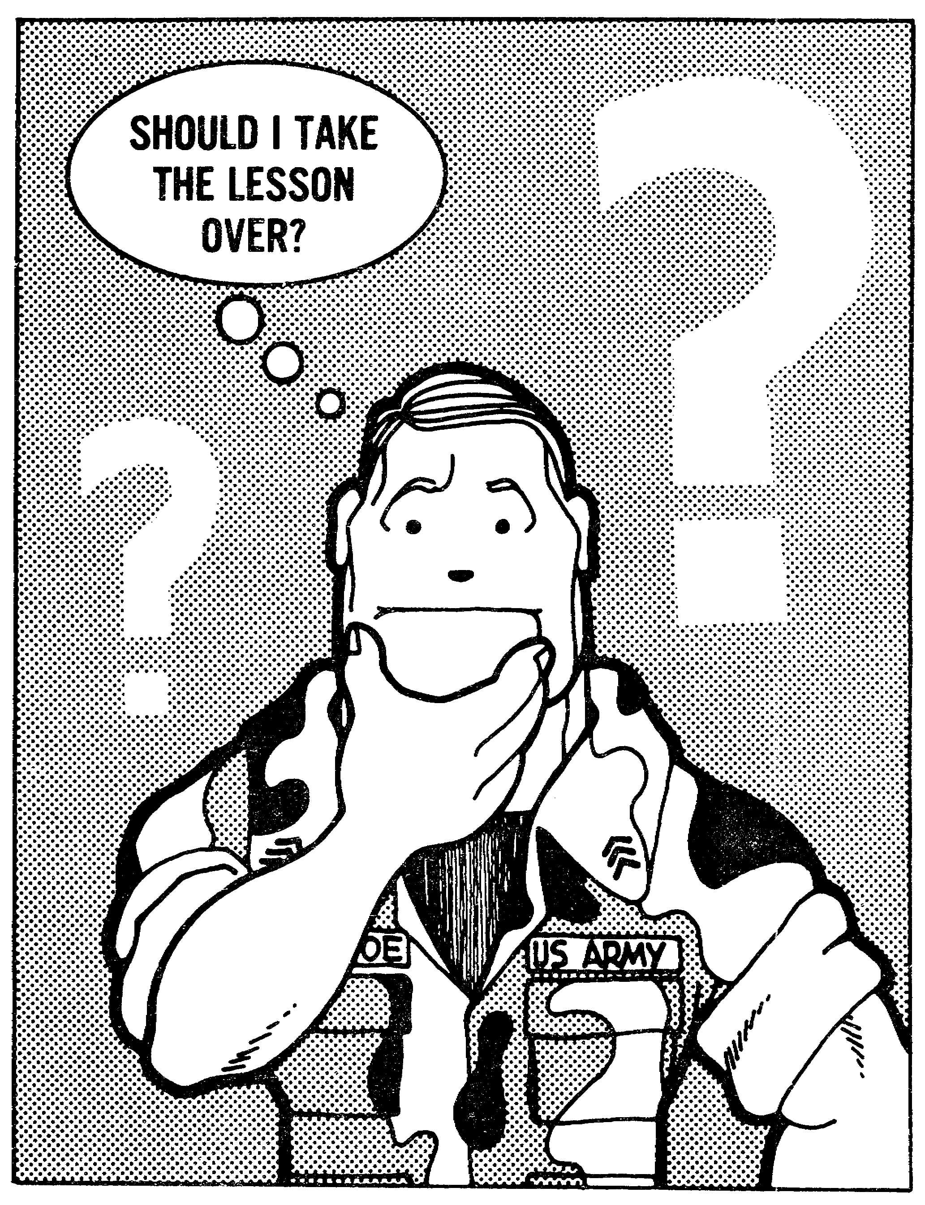

46

LESSON 3
SUPERVISE THE EXECUTION OF
DUTIES OF NET CONTROL STATION

TASK

Supervise the execution of duties of NCS.

CONDITIONS

Given changing and non-changing SOI data, a net assignment, and information contained in ACP 125(*) with US Supplement 1, and TC 24-19.

STANDARDS

Identify the proper procedures to open, direct traffic in, maintain transmission in, and close a radio net IAW ACP 125(*) with US Supplement 1, TC 24-19, and the SOI by correctly responding to 85% of the multiple-choice test.

REFERENCES

EXTRACTS OF ACP 125(*) with US Supplement 1
TC 24-19
SOI

Learning Event 1:
IDENTIFY THE PROPER PROCEDURES TO OPEN A RADIO NET

1. The NCS is the authority within a radio net for proper control and adherence to operating rules by the stations within the net. When the stations follow proper procedures, and the NCS maintains proper control, the net will be able to maintain an exchange of traffic with minimum delay. As the NCS, your responsibility will be to initiate a radio net following the prescribed procedures. Once established, the net must be controlled to ensure that traffic is exchanged freely, with considerations toward security.

2. The type of net and method of operation is determined from consideration of the operational factors involved. The unit SOP or operations order may dictate the type of net operation. Nets will be operated in one of two methods.

a. Free Net. In this type of net, the NCS authorizes stations to transmit without prior permission. Free net operation does not relieve the NCS of the responsibility for maintaining circuit discipline. In a free net, the NCSs role in the minute-by-minute operation will not normally be evident. A net is deemed to be free unless otherwise ordered.

47

b. Directed Net. Once a net is ordered to be directed, the NCS will exercise control of the number, length, and type of transmissions. Messages are to be transmitted only with prior permission from the NCS. An exception to this rule are messages of FLASH precedence, which may be sent directly. Messages may also be transmitted according to a predetermined schedule. This may reduce the number of unnecessary transmissions.

Occasionally it may be necessary to change a free net to a directed net or vice versa. To accomplish this, the NCS uses the phrase, "this is a directed net," or "this is a free net".

3. As discussed in Lesson 2, various calls and call signs may be used on a radio net. Calls are identified as single or multiple. Call signs are individual, collective, or net call signs. Refer to Lesson 2, Learning Event 1, for the definitions.

4. The procedures used to establish a net will be used when opening a net for the first time, or when reopening a net. A scheduled frequency change is not considered a reopening of a net. Therefore, there will be no net call-up during a scheduled frequency change unless it is considered essential to continuity of communications. The procedures outlined in paragraph 5, Example A, Learning Event 1, Lesson 2, will be followed when establishing communications.

Learning Event 2:
IDENTIFY THE PROPER PROCEDURES FOR DIRECTING TRAFFIC IN A RADIO
NET

1. In a directed net, the NCS will control the flow of traffic. The requirement for stations to request permission to transmit enables the NCS to screen all traffic prior to its transmission. Messages will be transmitted in the order of their precedence. The messages with the highest precedence will be transmitted first. The single exception to this rule pertains to FLASH precedence messages. Permission is not required for the transmission of FLASH messages, which will be sent direct.

2. When a net has been established, the NCS will announce a directed or free net. When announcing a directed net, the NCS will also request the amount and precedence of traffic for transmission. The example below illustrates the manner in which the NCS announces that the net is directed and requests the amount and precedence of traffic.

48

EXAMPLE 1

L4E28 transmits:

Lima Four Echo - THIS IS Echo Two Eight - This is a directed net - of what precedence and for whom are your messages - OVER

Each subordinate station then answers in alphanumeric order based on the abbreviated call sign indicating traffic on hand:

(Echo Two Eight) - THIS IS Alfa One Six Mike - One IMMEDIATE and one ROUTINE for you - OVER

(Echo Two Eight) - THIS IS Charlie Two Two Mike - No traffic -OVER

(Echo Two Eight) - THIS IS Delta Two Two Mike - ROUTINE for Alfa One Six - OVER

(Echo Two Eight) - THIS IS Foxtrot Two Two Mike - PRIORITY for Hotel Six Five - OVER

(Echo Two Eight) - THIS IS Hotel Six Five Mike - No traffic - OVER

(Echo Two Eight) - THIS IS Mike Six Three Mike - No traffic - OVER

L4E28 then informs the stations that their transmissions have been heard and commences to clear traffic in order of precedence:

Lima Four Echo - THIS IS Echo Two Eight - ROGER - Alfa One Six Mike - Send your IMMEDIATE - OVER

After B6A16M completes the IMMEDIATE to L4E28, the NCS orders the station with the next highest precedence message to transmit their message:

Foxtrot Two Two Mike - THIS IS Echo Two Eight - Send your PRIORITY - OUT

L2H65M, hearing the authorization, tells S4F22M to go ahead:

(THIS IS) Hotel Six Five Mike - OVER

(Failure of L2H65M to answer immediately would necessitate S4F22M making a preliminary call to L2H65M).

Hotel Six Five Mike - THIS IS Foxtrot Two Two Mike - PRIORITY - TIME - etc.

49

After L2H65M receipts for the message and transmits the proword OUT the NCS continues to authorize stations to transmit their messages in order of precedence until the traffic list is cleared.

When the traffic list is cleared, stations having messages to transmit should call the NCS and request permission to transmit.

EXAMPLE 2

L2H65M, having one ROUTINE message for J3C22M, transmits:

Echo Two Eight - THIS IS Hotel Six Five Mike - ROUTINE for Charlie Two Two Mike - OVER

L4E28 transmits:

THIS IS Echo Two Eight - Send your message - OUT or, if higher precedence traffic is awaiting transmission:

THIS IS Echo Two Eight - WAIT - OUT

When circuit conditions permit, L4E28 informs L2H65M that they may transmit their message:

Hotel Six Five Mike - THIS IS Echo Two Eight - Send your message - OUT

J3C22M hearing the authorization, should then transmit:

(THIS IS) Charlie Two Two Mike - OVER

This procedure avoids requiring L2H65M to make a preliminary call. Then L2H65M proceeds with the transmission of their ROUTINE message.

3. During difficult working conditions or when the NCS must leave the net, specific procedures will be used to delegate the authority of NCS to a subordinate station. The NCS will delegate control of the net to the subordinate station in the best position to control the operation of the net. In such cases the term assume net control will be used. An example of a subordinate station directed to assume net control is shown as follows:

The NCS is closing down for 30 minutes and decides that B2D22M is in the best position to assume net control.

50

L4E28 then transmits:

Lima Four Echo - THIS IS Echo Two Eight - am leaving the net for three zero minutes - Delta Two Two Mike - Assume net control - OVER

Echo Two Eight - THIS IS Delta Two Two Mike - AUTHENTICATE - Lima Oscar - OVER

Lima Four Echo - THIS IS Echo Two Eight - I AUTHENTICATE Xray - OVER

Echo Two Eight - THIS IS Delta Two Two Mike - ROGER - OUT

Echo Two Eight - THIS IS Foxtrot Two Two Mike - ROGER - OUT

(Each station in the net then answers in sequence)

NOTE: Words, groups, or phrases are transmitted twice and preliminary calls should be used during difficult conditions!

4. Occasions may arise when the NCS must leave the net without prior notification. In such cases, the first subordinate station in order of reply will assume net control station responsibilities. An example of the first subordinate station assuming net control is as follows:

Nothing has been heard from the NCS. Subordinate station B6A16M as first subordinate station transmits:

Lima Four Echo - THIS IS Alfa One Six Mike - Have you heard anything from Echo Two Eight - OVER

There is no reply from the NCS and the other subordinate stations transmit:

(Alfa One Six Mike) - (THIS IS) Charlie Two Two Mike - NOTHING HEARD - OVER

(Alfa One Six Mike) - (THIS IS) Delta Two Two Mike - NOTHING HEARD - OVER

(Alfa One Six Mike) - (THIS IS) Foxtrot Two Two Mike - NOTHING HEARD - OVER

(Alfa One Six Mike) - (THIS IS) Hotel Six Five Mike - NOTHING HEARD - OVER

(Alfa One Six Mike) - (THIS IS) MIKE Six Three Mike - NOTHING HEARD - OVER

51

B6A16M then transmits:

(Lima Four Echo) - (THIS IS) Alfa One Six Mike - ROGER - Nothing heard from Echo Two Eight - I am assuming net control - OVER

Subordinate stations reply in order:

(Alfa One Six Mike) - (THIS IS) Charlie Two Two Mike - ROGER - OUT

(Alfa One Six Mike) - (THIS IS) Delta Two Two Mike - ROGER -OUT

(Alfa One Six Mike) - (THIS IS) Foxtrot Two Two Mike - ROGER - OUT

(Alfa One Six Mike) - (THIS IS) Hotel Six Five Mike - ROGER - OUT

(Alfa One Six Mike) - (THIS IS) Mike Six Three Mike - ROGER - OUT

5. The NCS has the authority to impose and/or lift emergency silence on a radio net. When an authentication system is in force, a station will authenticate a transmission which imposes or lifts emergency silence, or calls stations during a period of emergency silence. Transmissions imposing emergency silence will be made twice through and ended with the proword OUT. Stations do not answer or receipt for such transmissions.

a. SILENCE, spoken three times, means: Cease transmissions on this net immediately. Silence will be maintained until lifted.

b. After a call, use of the proword SILENCE (spoken three time) means, "Stations addressed cease all transmissions on this net immediately."

EXAMPLE 1

To impose emergency silence on the net, L4E28 transmits:

Lima Four Echo - THIS IS Echo Two Eight - SILENCE SILENCE SILENCE - TIME Zero Nine One Six Zulu AUTHENTICATION IS Charlie Foxtrot - I SAY AGAIN Lima Four Echo - THIS IS Echo Two Eight - SILENCE SILENCE SILENCE - TIME Zero Nine One Six Zulu AUTHENTICATION IS Charlie Foxtrot - OUT

52

To impose emergency silence during the transmission of a message by another station, L4E28 waits for a pause, then transmits:

SILENCE SILENCE SILENCE - Lima Four Echo - THIS IS Echo Two Eight SILENCE SILENCE SILENCE - AUTHENTICATION IS Gulf Papa - I SAY AGAIN Lima Four Echo - THIS IS Echo Two Eight SILENCE SILENCE SILENCE - AUTHENTICATION IS Gulf Papa - OUT

c. SILENCE (spoken three times), followed by a frequency or frequency designator means, "Cease all transmission immediately on frequency ____ (or that indicated by frequency designator)."

d. SILENCE (spoken three times), followed by all nets, means, "Cease all transmissions immediately on all nets."

e. To lift emergency silence to all stations on the net, L4E28 transmits:

EXAMPLE 2

Lima Four Echo - THIS IS Echo Two Eight - SILENCE LIFTED - AUTHENTICATION IS Yankee Sierra - OUT (OVER, as appropriate)

When emergency silence is lifted after a prolonged period of silence, communication will be established with all stations as in paragraph 5, example A, lesson 2.

Learning Event 3:
IDENTIFY THE PROPER PROCEDURES
FOR CLOSING A RADIO NET

1. A radio net will be closed only with proper authority. Operations orders commonly include the time for operation of a net, and dictate the time at which a net will close. Other situations will preclude the closing of a net until the mission has been accomplished.

2. From time to time individual stations may be required to close down for various reasons. At those times, a request will be made to the NCS to close down for a specified period of time. Stations that do not normally operate in a net may request to leave the net for an indefinite period of time.

EXAMPLE 1

B2D22M is operating in a net in which he is a substation.

B2D22M is changing locations and will not be able to operate mobile.

53

Echo Two Eight - THIS IS Delta Two Two Mike - Request permission to CLOSE DOWN (Until ____) - OVER

L4E28, having received the request transmits:

(Delta Two Two Mike) - (THIS IS) Echo Two Eight - ROGER - OUT

(In nonsecure nets authentication will be used)

Z5Y27 is leaving a net in which he does not normally operate.

Echo Two Eight - THIS IS Yankee Two Seven - Request permission to leave the net - OVER

L4E28, having heard the request transmits:

(Yankee Two Seven) - (THIS IS ) Echo Two Eight - ROGER - OUT

3. When closing a net, the NCS will give the order to close down using the proword CLOSE DOWN. After receiving the order to close down, the first substation will challenge the NCS to authenticate as shown below.

(Authentication is optional in secure nets)

L4E28 has received a directive to close down the net and transmits:

Lima Four Echo - THIS IS Echo Two Eight - CLOSE DOWN - OVER

Having received the order to close down, B6A16M transmits:

Echo Two Eight - THIS IS Alfa One Six Mike - AUTHENTICATE - Lima Bravo - OVER

L4E28 transmits:

Alfa One Six Mike - THIS IS Echo Two Eight - I AUTHENTICATE Tango - OVER

Echo Two Eight - THIS IS Alfa One Six Mike - ROGER - OUT

The remaining substations respond in alphanumeric order as follows:

Echo Two Eight - THIS IS Charlie Two Two Mike - ROGER - OUT

Echo Two Eight - THIS IS Delta Two Two Mike - ROGER - OUT

Echo Two Eight - THIS IS Foxtrot Two Two Mike - ROGER - OUT

Echo Two Eight - THIS IS Hotel Six Five Mike - ROGER - OUT

54

Learning Event 4:
IDENTIFY THE PROCEDURES FOR REQUIRING
STATIONS TO AUTHENTICATE AND MAINTAINING
TRANSMISSION SECURITY IN A RADIO NET

1. Authentication systems are provided to prevent unauthorized (enemy) stations from entering friendly radio nets to disrupt or confuse operations (deception). The NCS will monitor operations to ensure that authentication is being used where necessary, practical, and in the interest of security.

2. The NCS or any substation will issue a challenge when imitative deception is suspected on the net. The NCS will authenticate (transmission authentication) when directing radio silence, listening silence, or when requiring a station to break an imposed silence. stations will be required to authenticate when transmitting contact or amplifying reports or transmitting a plain language cancellation. When a station transmits instructions that affect the military situation, that station will be challenged to authenticate. When stations establish initial communications or resume contact after a prolonged interruption, authentication will be used. If authorized to transmit a classified message in the clear or a station must transmit a message in the blind, transmission authentication will be used. Authentication is not required when making initial contact after a scheduled call sign and frequency change.

3. When a caller desires to authenticate, he must invite a challenge by stating that he is prepared to authenticate. A station will be challenged a second time when: an incorrect reply is received, a standby is requested, or an unusual delay occurs between challenge and reply. There is no self-authentication, consequently, a challenge and reply will not be given in the same transmission. Transmission authentication is used to validate the authenticity of the message when it is impossible or impractical to use challenge/reply authentication.

4. Transmission security includes all measures taken to protect transmissions from interception, traffic analysis, and imitative deception. The NCS will monitor net traffic to ensure transmission security procedures are being followed by all operators. Transmission security will be enforced by the NCS during every communications period. The NCS will ensure operators practice the following transmission security measures:

a. Keep transmissions as short as possible.
b. Follow authorized transmission procedures.
c. Maintain circuit discipline.
d. Properly orient transmitting antenna.
e. Use a dummy antenna for tuning and maintenance of transmitters.

55

f. Avoid unnecessary transmission and excessive tuning.
g. Operate radios at the lowest possible power levels that will give satisfactory communications.
h. Use only authorized call signs, prosigns and prowords, and operating signals.
i. Authenticate in all instances prescribed by the authentication instructions in the SOI.
j. Report all instances of transmission security violations.
k. Follow abbreviated procedures outlined in Lesson 2, Learning Event 2, paragraph 3.

5. As a remedial action, a MIJI 1 (Meaconing, Intrusion, Jamming, Interference) report will be submitted by the operator for each suspected MIJI incident. The MIJI 1 report contains only those items of information necessary to inform the headquarters of the incident. The simple six-line format for the MIJI 1 report permits quick notification of the appropriate members of the command. The format for the MIJI 1 report is as follows:

ITEM 1 - Type report.
The term MIJI 1 is used as item 1 of the MIJI I report when being transmitted by secure means. When being transmitted over nonsecure systems, the numerals 022 are encrypted as item 1.

ITEM 2 - Type MIJI incident.
The appropriate term from the list below is used as item 2 of the MIJI 1 report when transmitted by secure means. The appropriate numeral preceding one of the items below is encrypted as item 2 when being transmitted over nonsecure means.

1 MEACONING
2 INTRUSION
3 JAMMING
4 INTERFERENCE

ITEM 3 - Type of equipment affected.
When being transmitted over secure means, the appropriate term below is transmitted as item 3 of the MIJI 1 report. The appropriate numeral preceding one of the items below is encrypted as item 3 when-being transmitted over nonsecure means.

1 RADIO
2 RADAR
3 NAVIGATIONAL AID
4 SATELLITE
5 ELECTRO-OPTICS

56

ITEM 4 - Frequency or channel affected.
When being transmitted over nonsecure means, the frequency or channel affected by the MIJI incident will be encrypted as item 4 of the MIJI 1 report. When being transmitted over secure means, the frequency or channel affected by the MIJI incident is item 4 of the report.

ITEM 5 - Call sign of affected station operator.
The complete call sign of the affected station operator is item 5 of the MIJI 1 report over both secure and nonsecure means of communications.

ITEM 6 - Coordinates of the affected station.
When being transmitted over nonsecure means, the complete grid coordinates of the affected station will be encrypted as item 6 of the MIJI 1 report. When transmitted over secure means the complete grid coordinates are item 6 of the MIJI 1 report.

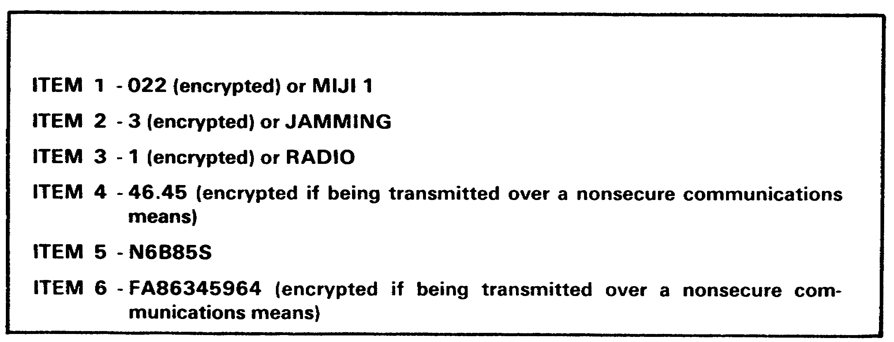

Figure 3-1. Sample Completed MIJI Report.

The MIJI 1 report is submitted by the operator to the NCS as soon as the tactical situation and/or operating conditions permit. In cases where the interference is overwhelming, the MIJI 1 report should be delivered by an alternate method. The NCS will immediately report all MIJI to the Signal officer. A follow-up report will be submitted within 12 hours of the initial report providing all details of the incident.

57

Using transmission security is absolutely essential for the radio operator. When the radio must be used, keep transmission time to an absolute minimum (20 seconds absolute maximum; 15 seconds preferred). Preplan your messages, use brevity lists, if possible, and encrypt the message. These measures will decrease your transmission time, help protect you from radio direction finding, and deny the enemy valuable information.

58

Lesson 3

PRACTICE EXERCISE

1. Authentication systems are designed to prevent which of the following?

a. deception
b. jamming
c. interference
d. meaconing

2. In a directed net, no permission is required to transmit a ___________ message.

a. service
b. immediate
c. flash
d. priority

3. In a directed net, the NCS authorizes the transmission of messages according to ____________________.

a. alphanumeric order of call signs
b. precedence
c. date-time group
d. classification

4. When the NCS leaves the net without prior notification, the __________assumes control of the net.

a. first substation in order of reply
b. station detecting the NCS absence.
c. station in the best position to control the net
d. alternate NCS

5. Transmissions imposing emergency silence will be _________________.

a. transmitted twice and include challenge and reply authentication
b. transmitted once and ended with the proword OUT
c. transmitted once and ended with the proword OVER
d. transmitted twice and ended with the proword OUT

59

Lesson 3

Supervise the Execution of the Duties of Net
Control Station

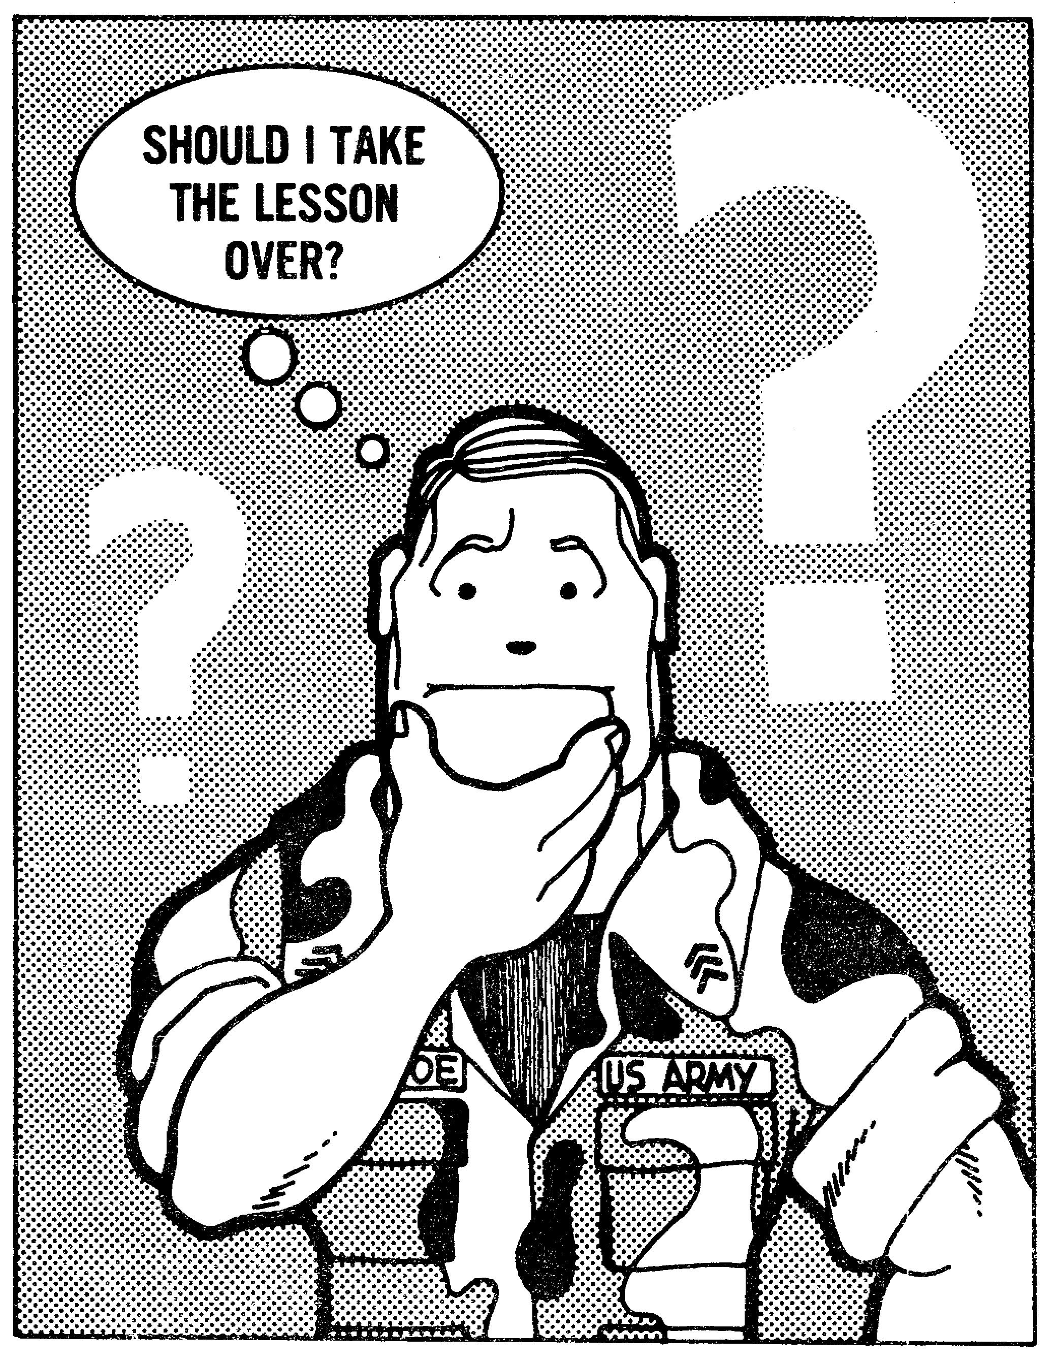

60

ANSWERS TO PRACTICE EXERCISES
LESSON 1

Answer Reference

Learning Events 1 and 2

1. c Learning Event 1, para 1
2. d Learning Event 1, para 3
3. b Learning Event 1, fig 1-2
4. a Learning Event 1, para 5
5. b Learning Event 1, fig 1-4

Learning Events 3 and 4

1. b fig 1-11
2. a fig 1-11
3. d fig 1-12
4. c fig 1-13
5. b Learning Event 4, para 3

Lesson 2

Answer Reference

Learning Event 1

1. c Learning Event 1, para 1
2. d Learning Event 1, para 3
3. b Learning Event 1, para 4
4. b Learning Event 1, para 4
5. b Learning Event 1, para 4

Learning Event 2

1. d Learning Event 2, para 2
2. a Learning Event 2, para 3
3. c Learning Event 2, para 8
4. a Learning Event 2, para 11
5. d Learning Event 2, para 14

Lesson 3

Answer Reference

1. a Learning Event 4, para 1
2. c Learning Event 1, para 2b
3. b Learning Event 2, para 1
4. a Learning Event 2, para 4
5. d Learning Event 2, para 5

61

